This is compressed, high-signal, and focuses on what is testable rather than narrative detail.

✅ Semantic Models in Microsoft Fabric — Exam Summary

1️⃣ Semantic Models & DAX Fundamentals

Purpose of Semantic Models
- Semantic models contain tables, relationships, calculations, and metadata
- Used to summarize, filter, and analyze data
- Built on top of Power Query–loaded data

Types of DAX Calculations
You can create three types of calculations:
- Calculated Tables
  - Used for:
    - Date tables
    - Role-playing dimensions
    - What-if analysis
- Calculated Columns
  - Row-by-row calculations
  - Stored in the model
- Measures
  - Dynamic aggregations
  - Evaluated at query time

2️⃣ Calculated Columns (Row Context)

When to Use Calculated Columns
✅ Use when:
- Logic depends on row context
- Requires DAX functions like:
  - RELATED
  - RELATEDTABLE
  - Parent-child functions
🚫 Avoid when:
- A measure can do the same job
- Large tables → increases model size & refresh time

Row Context
- Calculated columns are evaluated one row at a time
- 'Table'[Column] refers to the current row
- Row context:
  - Exists in calculated columns
  - Exists inside iterator functions (SUMX, AVERAGEX)

Cross-Table Access in Columns
- RELATED() → get value from one-side
- RELATEDTABLE() → get table from many-side
- LOOKUPVALUE() → use only if no relationship exists

3️⃣ Measures vs Calculated Columns (VERY EXAM-HEAVY)
Feature | Calculated Column | Measure
Evaluation | Data refresh time | Query time
Context | Row context | Filter context
Storage | Stored per row | Not stored
Performance | Increases model size | Efficient
Best For | Slicing, relationships | Aggregations
✅ Always prefer measures when possible

4️⃣ Implicit vs Explicit Measures

Implicit Measures
- Automatically created when dragging numeric columns into visuals
- Default aggregations:
  - Sum
  - Average
  - Count
- Can be changed by report authors (risk!)
⚠️ Limitation:
- Only simple aggregations
- Cannot do ratios, time intelligence, or complex logic

Explicit Measures
- Written using DAX
- Required for:
  - Ratios
  - Time intelligence
  - Complex business logic

5️⃣ Iterator Functions (X Functions)

What They Do
- Iterate row-by-row over a table
- Use row context internally
- Return a single value

Common Iterators
- SUMX
- AVERAGEX
- COUNTX
- RANKX

Performance Rule
✅ Use when necessary
🚫 Avoid heavy expressions on large tables

6️⃣ Ranking with RANKX

Key Concepts
- Default: Descending, skips ranks
- Use DENSE for continuous ranking
- Use HASONEVALUE() to avoid ranking totals

7️⃣ Storage Modes (VERY IMPORTANT)

Storage Options
- Import ✅ (Preferred)
- DirectQuery
- Direct Lake
- Composite

Import Mode
- Best performance
- Data stored in VertiPaq
- Requires refresh
- Optimize by:
  - Removing unused columns
  - Reducing rows
  - Correct data types

DirectQuery
- Real-time access
- Slower performance
- Limited modeling
- Depends heavily on source performance

Direct Lake
- Reads Delta tables directly from Fabric Lakehouse
- Fast access to large data
- Supports fallback to DirectQuery

Composite Models
- Mix Import + DirectQuery
- Supports many-to-many
- Can impact performance if poorly designed

8️⃣ Relationships & Modeling

Star Schema (EXAM FAVORITE)
- Fact table in center
- Dimension tables around
- Filters flow dimension → fact

Relationship Types
- One-to-Many ✅ (most common)
- One-to-One
- Many-to-Many (use bridge tables)

Best Practices
- Avoid bi-directional filters
- Use USERELATIONSHIP() for inactive relationships

9️⃣ Disconnected Tables
- Not related to other tables
- Used for:
  - What-if parameters
  - User input
- Do not propagate filters

🔟 Advanced DAX Writing

Variables (VAR)
Benefits:
- Improves performance
- Improves readability
- Eliminates need for EARLIER

Filter Context Functions
- CALCULATE
- FILTER
- ALL
- KEEPFILTERS (faster than FILTER)

Window Functions
- OFFSET
- INDEX
- WINDOW Used for:
- Running totals
- Comparisons

1️⃣1️⃣ Dynamic Model Features

Calculation Groups
- Reusable calculations (YTD, QTD, MTD)
- Use SELECTEDMEASURE()
- Reduce measure explosion

Field Parameters
- Let users switch dimensions/measures dynamically
- Improve performance vs bookmarks

Dynamic Format Strings
- Change formatting based on values
- Often combined with calculation groups

1️⃣2️⃣ Performance Optimization

Key Techniques
- Reduce cardinality
- Remove unused columns
- Disable Auto Date/Time when using custom date table
- Use aggregations

Performance Analyzer
- Measures:
  - DAX query time
  - Visual render time
- Use with cleared cache for accuracy

1️⃣3️⃣ Aggregations
- Pre-summarized tables
- Improve:
  - Query speed
  - Refresh time
- Managed via Manage Aggregations

1️⃣4️⃣ Reusable Assets & Lifecycle

Core vs Specialized Models
- Core model = single source of truth
- Specialized models = regional or domain-specific

Power BI Project Files (.pbip)
- Text-based
- Git-friendly
- Enables CI/CD

1️⃣5️⃣ Security (EXAM-CRITICAL)

Row-Level Security (RLS)
- Static rules → hardcoded
- Dynamic rules → USERPRINCIPALNAME() ✅

Object-Level Security (OLS)
- Secures tables/columns
- Requires XMLA endpoint
- Cannot mix with RLS in same role

✅ FINAL EXAM TAKEAWAYS
- ✅ Prefer measures over calculated columns
- ✅ Use star schema
- ✅ Reduce model size aggressively
- ✅ Use calculation groups for scalability
- ✅ Variables = performance + readability
- ✅ Import mode whenever possible
- ✅ Avoid bi-directional filters
- ✅ Use USERPRINCIPALNAME() for RLS

Work with semantic models in Microsoft Fabric
Create DAX calculations in semantic models
When you first create a semantic model by applying Power Query queries, the model consists of tables and columns. At this point, the model probably isn't ready for use. That's because you might need to create or adjust model relationships, create other tables or columns, add hierarchies, or set model properties. You might also identify the need for calculations to summarize the model data, especially when the requirement can't be achieved by summarizing a single column. For example, you might want to calculate year-to-date (YTD) sales revenue, which requires special time filters.
You can use Data Analysis Expressions (DAX) to add three types of calculations to your semantic model to complete your model design:
- Calculated tables, which can be useful to create date tables or role-playing dimensions, or to enable what-if analysis.
- Calculated columns, which can be added to tables in your model.
- Measures, which achieve summarization over model data.

Create calculated columns
Completed100 XP
- 6 minutes
Occasionally, you need more columns than exist in your data. Ideally, you add these columns directly to the data source, which supports easier maintenance and allows the column logic to be reused in other models or reports. However, if you need to add the column once connected to the data in Power BI, you can either create a custom column in Power Query Editor or add a calculated column to the semantic model. No matter how you add the column, the result is the same from a report user's perspective.
In general, custom columns in Power Query are preferred because they're loaded into the model in a more compact and optimal way. Calculated columns are recommended only when adding columns to a calculated table or when the formula:
- Depends on summarized model data.
- Requires specialized modeling functions available only in DAX, such as RELATED, RELATEDTABLE, or functions for parent-child hierarchies.

Create calculated columns
A DAX formula can be used to add a calculated column to any table in the model. The formula must return a single value (scalar) for each row.
Calculated columns in import models increase storage size and can prolong data refresh times, especially when they depend on other tables that are refreshed. Therefore, be cautious when using too many calculated columns and consider if a measure can be used instead.
In the following examples, several calculated columns are created to support fiscal analysis to demonstrate the versatility of calculated columns.

Fiscal Year
This column determines the fiscal year for each date. The fiscal year starts in July, so dates from July to December are assigned to the next calendar year. The formula concatenates "FY" with the year, incrementing the year by one for dates in the second half of the year.
DAX
Due Fiscal Year =
"FY"
& YEAR('Due Date'[Due Date])
+ IF(
MONTH('Due Date'[Due Date]) > 6,
1
)
The following steps describe how Microsoft Power BI evaluates the calculated column formula:
- The addition operator (+) is evaluated before the text concatenation operator (&).
- The YEAR function returns the whole number value of the due date year.
- The IF function returns the value when the due date month number is 7-12 (July to December); otherwise, it returns BLANK. (For example, because the Adventure Works financial year is July-June, the last six months of the calendar year will use the next calendar year as their financial year.)
- The year value is added to the value that is returned by the IF function, which is the value one or BLANK. If the value is BLANK, it's implicitly converted to zero (0) to allow the addition to produce the fiscal year value.
- The literal text value "FY" concatenated with the fiscal year value, which is implicitly converted to text.

Fiscal Quarter
This column assigns a fiscal quarter to each date, based on the fiscal year structure where Quarter 1 is July–September. The formula appends Q and the quarter number to the fiscal year label.
DAX
Due Fiscal Quarter =
'Due Date'[Due Fiscal Year] & " Q"
& IF(
MONTH('Due Date'[Due Date]) <= 3,
3,
IF(
MONTH('Due Date'[Due Date]) <= 6,
4,
IF(
MONTH('Due Date'[Due Date]) <= 9,
1,
2
)
)
)

Month Key
The MonthKey formula multiplies the due date year by the value 100 and then adds the month number of the due date. It produces a numeric value that can be used to sort the Due Month text values in chronological order.
DAX
MonthKey =
(YEAR('Due Date'[Due Date]) * 100) + MONTH('Due Date'[Due Date])

Full Date Label
The FORMAT function converts the Due Date column value to text by using a format string. In this case, the format string produces a label that describes the year, abbreviated month name, and day:
DAX
Due Full Date =
FORMAT('Due Date'[Due Date], "yyyy mmm, dd")
Note
Many user-defined date/time formats exist. For more information, see Custom date and time formats for the FORMAT function.
After these additions, the Due Date table contains six columns: the original date column and five calculated columns. These columns support both time intelligence functions and readability for report consumers.
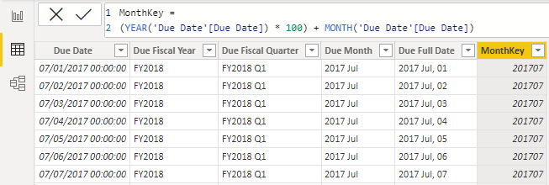

Understand row context
Power BI evaluates a calculated column’s formula for each row in the table, which is called row context. Row context just means “the current row.” For example, here’s the Due Fiscal Year calculated column:
DAX
Due Fiscal Year =
"FY"
& YEAR('Due Date'[Due Date])
+ IF(
MONTH('Due Date'[Due Date]) <= 6,
1
)
When Power BI runs this formula, 'Due Date'[Due Date] gives the value from the current row. If you’ve used Excel tables, this idea might feel familiar.
Row context only applies to the current table. If you need values from another table, you have two main options:
- If a relationship exists between the two tables, use the RELATED or RELATEDTABLE function. RELATED gets a value from the one-side of a relationship. RELATEDTABLE gets a table of values from the many-side.
- If there's no relationship, use the LOOKUPVALUE function.
Try to use RELATED when you can. It usually works faster than LOOKUPVALUE because of how Power BI stores and indexes data.
Here’s an example. This formula adds a Discount Amount column to the Sales table:
DAX
Discount Amount =
(
Sales[Order Quantity]
* RELATED('Product'[List Price])
) - Sales[Sales Amount]
Power BI calculates this formula for each row in the Sales table. It gets Order Quantity and Sales Amount from the current row. To get List Price from the Product table, it uses the RELATED function to find the right value for each sale.
Row context always applies when Power BI evaluates calculated column formulas. It also comes into play with iterator functions, which let you create more advanced summaries.

Understand implicit measures
Completed100 XP
- 6 minutes
Measures in Power BI models are either implicit or explicit. Implicit measures are automatic behaviors that let visuals summarize column data. Explicit measures, often called measures, are calculations you add to your model. This section explains how implicit measures work and how you can use them.

Identify implicit measures
As a data modeler, you control how a column summarizes by setting the Summarization property. You can choose Don't summarize or select a specific aggregation function. If you set a column to Don't summarize, the sigma symbol disappears in the Data pane.
In the Data pane, a column with the sigma symbol (∑) shows two facts:
- The column is numeric.
- Values are summarized when used in a visual that supports summarization.
The following image shows the Sales table with implicit measures, a calculated column, and one column that can't be summarized.
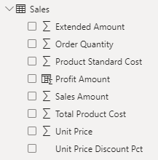
Notice in the example with the Sales table, if you add the Sales Amount field from the Sales table to a matrix visual that groups by fiscal year and month, Power BI summarizes the values implicitly. The Sum aggregation function is selected by default.
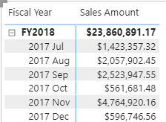
If you add the Unit Price field to the matrix visual, Power BI uses Average as the default summarization, because summing unit prices doesn’t make sense since they’re rates, not totals.
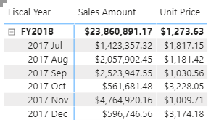
The default summarization is now set to Average (the modeler knows that it's inappropriate to sum unit price values together because they're rates, which are non-additive).
Implicit measures allow the report author to start with a default summarization technique and lets them modify it to suit their visual requirements. Numeric columns support the widest range of aggregation functions to choose from, including:
- Sum
- Average
- Minimum
- Maximum
- Count (Distinct)
- Count
- Standard deviation
- Variance
- Median

Summarize non-numeric columns
Non-numeric columns like text, dates, and boolean (true/false) values can also be summarized in your visuals. While the sigma symbol (∑) only appears next to numeric fields in the Data pane, these columns are still being aggregated.
- Text columns: First, Last, Count, Count (Distinct)
- Date columns: Earliest, Latest, Count, Count
This flexibility is useful when you want to answer questions such as:
- "How many unique products are there?" (Count distinct on a text column)
- "What was the earliest order date?" (Earliest on a date column)
- "How many orders were marked as complete?" (Count on a boolean column)
You can choose the aggregation option that best fits your analysis when you add a non-numeric field to your visual.

Considerations for implicit measures
Implicit measures are easy to use and flexible. They let report authors start with a default summarization and change it to fit their needs. Implicit measures let report authors quickly visualize data without needing to write calculations. As a data modeler, you spend less time creating explicit measures.
However, even if you set a default summarization, report authors can change it to something that might not make sense. For example, they could set Unit Price to Sum, which produces misleading results, as shown in the following image. The Unit Price values are large because they're the sum of unit prices instead of the static unit price per product.
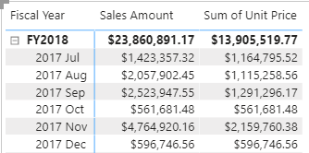
The biggest limitation is that implicit measures only work for simple scenarios. They can summarize column values using a single aggregation function, but they can’t handle more complex calculations. For example, if you need to calculate the ratio of each month’s sales amount over the yearly sales amount, you must create an explicit measure with a DAX formula.

Create explicit measures
Completed100 XP
- 7 minutes
You can add a measure to any table in your model by writing a DAX formula. A measure formula must return a single value. This section explains how to create explicit measures.
Measures don’t store values in the model. Instead, Power BI calculates them at query time to summarize model data. Measures can’t reference a table or column directly, so you must use a function to summarize the data.

Simple measures
A simple measure aggregates the values of a single column, just like an implicit measure.
For example, you can add a measure to the Sales table. In the Data pane, select the Sales table. On the Table Tools ribbon, select New measure.
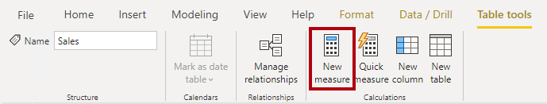
The following formula creates a measure called Revenue. This measure uses the SUM function to total the values in the Sales Amount column. If you add this measure to a table alongside the Sales Amount implicit measure, the results are the same.
DAX
Revenue =
SUM(Sales[Sales Amount])
Tip
Adding measures and hiding columns helps report authors use the explicit measures instead.
In the Measure tools contextual ribbon, you can format the measure, set data type, and change the home table. The home table refers to where the measure shows when looking at the data pane.
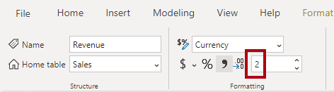
Tip
It's a good practice to set the formatting options right after you create a measure. This ensures your values look consistent in all report visuals.
Consider you might need a measure to calculate Profit as shown in the following code:
DAX
Profit =
SUM(Sales[Profit Amount])
In this example, the Profit Amount column is a calculated column. This approach isn’t optimal because you don’t need that column. In the next section, you see how to create a measure that calculates profit directly, which reduces model size and improves refresh times.
The following code creates two different measures to return Order Line Count and Order Count. The COUNT function counts non-BLANK values in a column. The DISTINCTCOUNT function counts unique values. Since an order can have multiple order lines, the Sales Order column has duplicates. Using DISTINCTCOUNT gives you the correct order count.
DAX
Order Line Count =
COUNT(Sales[SalesOrderLineKey])

Order Count =
DISTINCTCOUNT('Sales Order'[Sales Order])
You can also write the Order Line Count measure using COUNTROWS, which counts the number of rows in a table:
DAX
Order Line Count =
COUNTROWS(Sales)
All the measures referenced are considered simple measures because they aggregate a single column or single table.
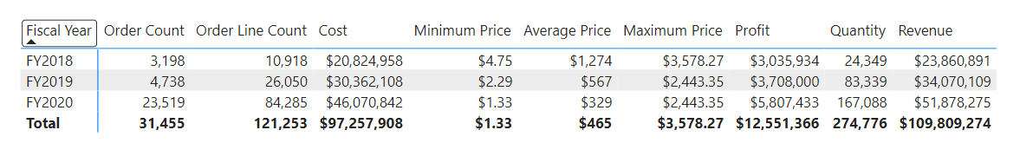

Create compound measures
A compound measure references one or more other measures. For example, you can redefine the Profit measure by referencing other measures. This measure can be used instead of the calculated column previously referenced.
DAX
Profit =
[Revenue] - [Cost]
This change to the model presents an important lesson: By removing the calculated column, you optimize the semantic model because it results in a decreased semantic model size and shorter data refresh times. The Profit Amount calculated column wasn't required after all because the Profit measure can directly produce the required result by using existing measures.
Note
Sometimes, it makes sense to define measures that depend on other measures. Always test changes carefully, because updates can affect all dependent measures.

Use Quick measures
Quick measures let you perform common calculations without writing DAX yourself. Power BI generates the DAX expression for you, which helps you learn and build your DAX skills.
For example, you can use a Quick measure to create a Profit Margin measure through the following steps:
- Select Quick measure in the Table tools ribbon.
- Choose Mathematical operations > Division.
- Add the Profit measure into Numerator and Revenue into Denominator.
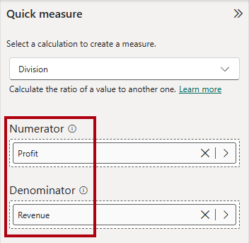
The new measure appears in the Data pane, and you can review its DAX formula:
DAX
Profit Margin =
DIVIDE([Profit], [Revenue])

Compare calculated columns and measures
Many DAX beginners find calculated columns and measures confusing at first. Both are created in the semantic model using DAX formulas, however, calculated columns and measures behave differently.
 | Calculated columns | Measures
Purpose | Adds a new column to a table | Defines how to summarize model data
Evaluation | Evaluated using row context at data refresh time | Evaluated using filter context at query time
Storage | Stores a value for each row in the table (Import mode) | Never stores values in the model
Use in visuals | Can filter, group, or summarize data (as implicit measures) | Designed specifically to summarize data
Performance impact | Can increase memory usage and model size | More efficient; better performance in large models
Ideal for | New fields for slicing or relationships | Dynamic calculations based on filters
Recognizing these differences helps you choose the right approach for your modeling and reporting needs.

Use iterator functions
Completed100 XP
- 7 minutes
Iterator functions evaluate an expression for each row in a table. They give you flexibility and control over how your model summarizes data.
Single-column summarization functions, such as SUM, COUNT, MIN, and MAX, have equivalent iterator functions with an "X" suffix, like SUMX, COUNTX, MINX, and MAXX. Specialized iterator functions also exist for filtering, ranking, and semi-additive calculations over time.
Every iterator function requires a table and an expression. The table can be a model table or any expression that returns a table. The expression must return a single value for each row.
Single-column summarization functions, like SUM, act as shorthand. Power BI internally converts SUM to SUMX. For example, both of the following measures return the same result and have the same performance:
DAX
Revenue = SUM(Sales[Sales Amount])
DAX
Revenue =
SUMX(
Sales,
Sales[Sales Amount]
)
Iterator functions evaluate the expression for each row in a table, using row context—meaning they process one row at a time to compute the final result. Then the table is evaluated in filter context. For example, if a report visual filters by fiscal year FY2020, the Sales table contains only sales rows from that year.
Important
Using iterator functions with large tables and complex expressions can slow performance. Functions like SEARCH and LOOKUPVALUE can be expensive. When possible, use RELATED for better performance.

Iterator functions for complex summarization
Iterator functions let you aggregate more than a single column. For example, a revenue measure can multiply order quantity, unit price, and a discount factor for each row, then sum the results.
DAX
Revenue =
SUMX(
Sales,
Sales[Order Quantity] * Sales[Unit Price] * (1 - Sales[Unit Price Discount Pct])
)
Iterator functions can also reference related tables. The discount measure can use the RELATED function to access the list price from the product table:
DAX
Discount =
SUMX(
Sales,
Sales[Order Quantity]
* (
RELATED('Product'[List Price]) - Sales[Unit Price]
)
)
The following image shows a table visual with the Month, Revenue, and Discount columns. Revenue and Discount are the measures previously created.
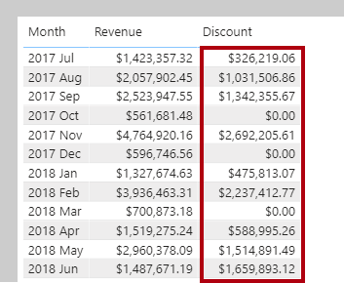

Iterator functions for higher grain summarization
Iterator functions can also summarize data at different levels of detail (grain). For example, you might want to calculate an average at the line item level or at the sales order level.
In this example, the Sales table contains one row for each line item in a sales order. Each row includes details such as the sales order number, product, quantity sold, unit price, and discount. Multiple rows can have the same sales order number, representing different items within the same order.
To calculate the average revenue per order line (line item), you can use the AVERAGEX function to iterate over each row in the Sales table. The formula calculates revenue for each line item, then averages the result across all line items in the current filter context:
DAX
Revenue Avg Order Line =
AVERAGEX(
Sales,
Sales[Order Quantity] * Sales[Unit Price] * (1 - Sales[Unit Price Discount Pct])
)
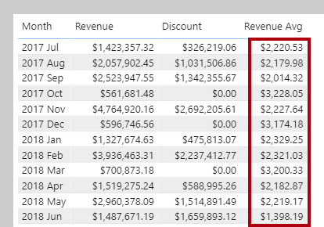
If you want to calculate the average revenue per sales order (rather than per line item), you can use the VALUES function to get a list of unique sales order numbers first. Then, AVERAGEX iterates over each sales order and averages the total revenue for each order:
DAX
Revenue Avg Order =
AVERAGEX(
VALUES('Sales Order'[Sales Order]),
[Revenue]
)
The VALUES function returns the unique sales orders based on the current filter context, so AVERAGEX iterates over each sales order for each month.
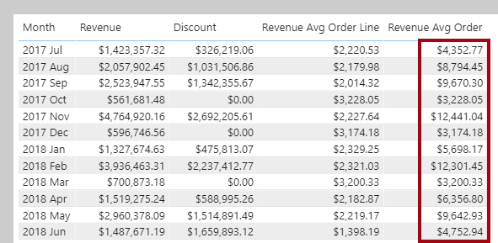

Ranking with iterator functions
The RANKX function calculates ranks by iterating over a table and evaluating an expression for each row.
Order direction can be ascending or descending. Ranking revenue usually uses descending order, so the highest value ranks first. Ranking something like complaints might use ascending order, so the lowest value ranks first. By default, RANKX uses descending order and skips ranks for ties.
For example, a product quantity rank measure can use RANKX and the ALL function to rank products by quantity:
DAX
Product Quantity Rank =
RANKX(
ALL('Product'[Product]),
[Quantity]
)
The ALL function removes filters, so RANKX ranks all products. In the following image, two products tie for tenth place, so the next product is ranked twelfth and rank 11 is skipped.
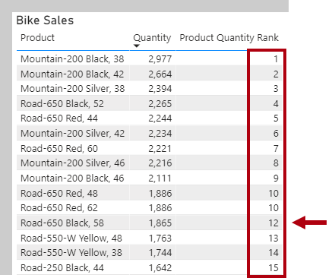
You can also use dense ranking, which assigns the next rank after a tie without skipping numbers. To use dense ranking, the measure can include the DENSE argument:
DAX
Product Quantity Rank =
RANKX(
ALL('Product'[Product]),
[Quantity],
,
,
DENSE
)
Now, after two products tie for tenth place, the next product is ranked eleventh and numbering continues sequentially without skipping rank 11.
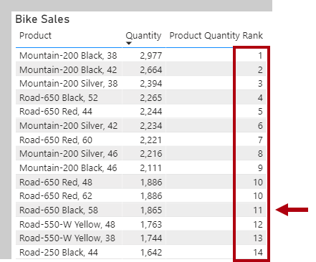
In this visual, the total row for the Product Quantity Rank measure shows one, because the total for all products is also ranked and there's only one value.
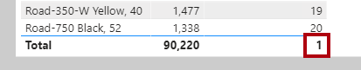
To avoid ranking the total, the measure can use the HASONEVALUE function to return BLANK unless a single product is filtered:
DAX
Product Quantity Rank =
IF(
HASONEVALUE('Product'[Product]),
RANKX(
ALL('Product'[Product]),
[Quantity],
,
,
DENSE
)
)
Now, the total for Product Quantity Rank is blank.
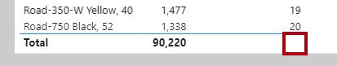
The HASONEVALUE function checks if the product column has a single value in filter context. This is true for each product group, but not for the total, which represents all products.
- An equivalent expression for HASONEVALUE() is COUNTROWS(VALUES(<columnName>)) = 1.
- This function is not supported for use in DirectQuery mode when used in calculated columns or row-level security (RLS) rules.

Iterator functions provide powerful ways to summarize, aggregate, and rank data in Power BI models. They support complex calculations and let you control the level of detail in your reports.
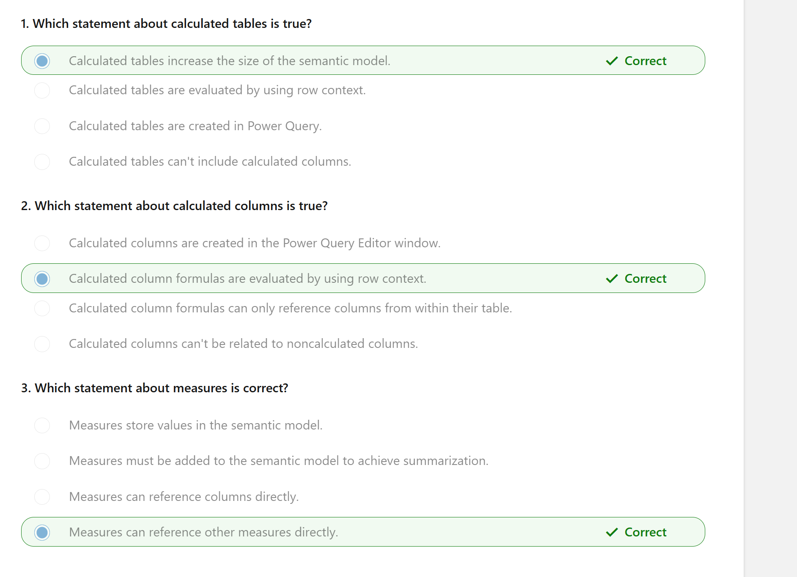
You learned the differences between calculated columns and measures, including when and how Power BI evaluates them and how they store data. Explicit measures are important because they allow you to create complex DAX formulas to achieve the precise calculations that your report visuals need.
You also learned how calculated columns are evaluated within row context, and iterator functions are available in measures for advanced row-by-row calculations.
Understanding how to create and use DAX calculatio

Design scalable semantic models
- Choose appropriate storage modes for your semantic model.
- Enable large semantic model storage format and incremental refresh.
- Create relationships between tables in a semantic model.
- Design dynamic elements to extend calculations in a semantic model.

Choose the best storage mode
Completed100 XP
- 6 minutes
When you design a scalable semantic model, selecting the appropriate storage mode is crucial. Depending on your data source, you have four options: Import, DirectQuery, Direct Lake, and Composite model. Each mode has its own advantages and considerations to ensure optimal performance and scalability.

Import Mode
Import involves importing and storing data within Power BI, offering the most flexibility and fastest performance. However, it requires periodic refreshes to keep the data current, meaning the data is only as up-to-date as the last refresh.
Guidance for Import models also applies to the other storage modes. You should always choose Import, if your model allows. The primary goal is to reduce how much data you bring into the semantic model and how many transformations are performed within Power BI. Optimization tips include:
- Connect to views instead of tables when working with relational databases.
- Only include necessary tables, rows, and columns.
- Consider partitioning and incremental refresh to avoid loading unnecessary data.
- Use appropriate data types, such as integer for ID columns instead of string.
- Ensure query folding, which reduces the work done within the Power BI engine.
Tip
Learn more about techniques to help reduce the data loaded into import models.

DirectQuery mode
DirectQuery allows you to query data directly from the source without storing it in Power BI, making it ideal for handling large volumes of data and near real-time data delivery. However, it has slower performance compared to Import Mode and offers limited modeling capabilities.
Optimization Tips:
- Avoid complex calculations at the source by simplifying Data Analysis Expressions (DAX).
- Apply dual storage mode for dimensions related to fact tables.
- Use the Assume Referential Integrity property on relationships.
- Avoid relationships on calculated and Unique Identifier columns.
Tip
See the documentation for more DirectQuery model guidance.

Direct Lake mode
Direct Lake allows querying data directly from a Microsoft Fabric lakehouse or warehouse without storing it in a semantic model, making it ideal for handling large volumes of data. This mode is optimized for quickly loading data into memory from Delta tables in Microsoft Fabric. While it offers the advantage of quick access to large data volumes, it requires the setup of a lakehouse or warehouse, and Delta tables might need to be tuned for optimal performance.
Optimization Tips:
- Configure Direct Lake to access ADLS (Azure Data Lake Storage) storage through shortcuts.
- Set up fallback behavior to DirectQuery for complex DAX queries.

Composite mode
Composite Mode mode can mix Import and DirectQuery modes, or integrate multiple DirectQuery data sources. This mode supports many-to-many relationships without the need for bridge tables. It offers the flexibility of querying and reporting capabilities by combining the benefits of both Import and DirectQuery modes. However, it requires periodic refreshes for Import mode tables and might have potential performance impacts when combining data from different sources.
Optimization Tips:
- Ensure the back-end source has sufficient resources.
- Minimize the number of literal values in source queries.
- Keep the cardinality of columns used in relationships low.
Tip
See the documentation for more Composite model guidance.
Configure incremental refresh and real-time data for Power BI semantic models - Power BI | Microsoft Learn
Advanced Incremental Refresh and Real-Time Data With the XMLA Endpoint in Power BI - Power BI | Microsoft Learn

Work with relationships
Completed100 XP
- 8 minutes
After choosing the model framework and transforming data, you need to create relationships to allow data to be filtered and aggregated based on data from another table. It’s common to create a star schema and enforce rules that filter dimension tables, allowing model relationships to efficiently apply those filters to fact tables.

Create a star schema
In our scenario, we imported a dimension table from .csv that needs to connect to the lakehouse. You can create relationships to shape a star schema after the imported table is transformed.
In a star schema, fact tables and dimension tables work together to organize and analyze data. The fact table stores the main data about business activities, like sales or events, while the dimension tables provide context and descriptive information about those activities.
For example, if you have a sales fact table, it might store data like the amount sold and the date of each sale. The dimension tables would then provide additional details, such as customer information, product details, and time periods. By linking the fact table to the dimension tables, you can easily filter, group, and analyze the data.
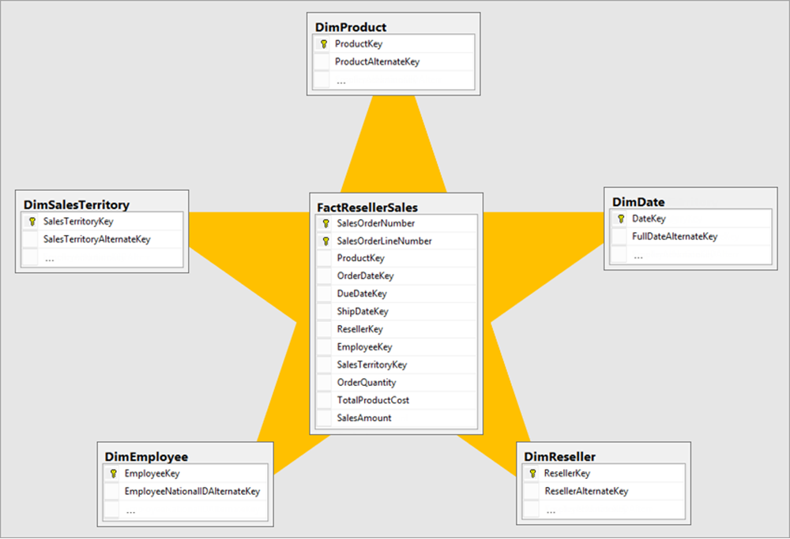

Create relationships
Creating relationships between fact and dimension tables is straightforward by identifying the related columns in each table and creating the relationship. In relational sources like databases or data warehouses, these columns are often known as keys. If key columns are absent, examine the tables to determine which columns to use for relationships.
Relationships come in different types:
- One-to-Many is the most common type, where one record in a table relates to multiple records in another. Typically, one-to-many is from a dimension table with one unique value to a fact table with many rows related to the one value.
- Many-to-One is essentially the same as One-to-Many, depending on which way the filter is configured between tables.
- One-to-One is less common as both tables have unique data. Consider if you need two tables or can combine them into a single table.
- Many-to-Many is less common but necessary for complex data. It allows multiple records in one table to relate to multiple records in another.
For many-to-many relationships, you might need to use a bridge table. A bridge table helps manage these relationships by linking the tables through intermediary keys. Composite models also assist with many-to-many relationships by allowing you to combine data from different sources.

Filter direction
When you create a relationship, you configure which direction the data is filtered from one table to another. In a star schema, the direction typically goes from the dimension table to the fact table, allowing the dimension table to filter the fact table's results.
Bi-directional filters are also possible and sometimes used in one-to-one or many-to-many relationships. Before using a bi-directional filter, ensure your data and relationships are correctly configured. Be cautious, as bi-directional filters can negatively affect model query performance and potentially confuse report users.
Referential integrity ensures that relationships between tables remain consistent. It means that every value in a foreign key column must have a corresponding value in the primary key column of the related table. This feature also improves query performance when using INNER joins as opposed to LEFT OUTER joins.
Understanding filter direction and referential integrity is crucial for accurate data modeling. Filters only propagate if the relationship path is intact and follows the defined direction. These configurations ensure data consistency and integrity across your model.

Inactive relationships
Relationships can be disabled and have their filter context modified by DAX functions. Sometimes, you need more than one relationship between tables, but only one can be active at a time between two tables. In such cases, use the USERELATIONSHIP function in DAX to reference inactive relationships to get the same filtering behavior. Here’s an example:
DAX
CALCULATE(
SUM(Sales[Amount]),
USERELATIONSHIP(Sales[Date], Calendar[Date])
)
Using DAX functions for relationships is valuable because they allow you to create dynamic and flexible calculations that can adapt to different data scenarios. This flexibility enables you to handle complex data models and perform advanced analytics that would be difficult to achieve with static relationships alone.

Use disconnected tables
It's unusual that a model table isn't related to another model table. Such a table in a valid model design is described as a disconnected table. A disconnected table isn't intended to propagate filters to other model tables. Instead, it accepts "user input" (perhaps with a slicer visual), allowing model calculations to use the input value in a meaningful way. For example, consider a disconnected table with a range of currency exchange rate values. When filtering by a single rate value, a measure expression can use that value to convert sales values.
The Power BI Desktop what-if parameter is a feature that creates a disconnected table. For more information, see Create and use a What if parameter to visualize variables in Power BI Desktop.

Write DAX for readability with complex calculations
Completed100 XP
- 5 minutes
DAX provides a powerful set of functions that allow you to create basic to complex calculations to measure the data in your semantic model in Power BI. By using filtering conditions, variables, and iterator, window, and information functions, you can create efficient and readable formulas.

Variables
Variables in DAX help you simplify your expressions and improve performance by storing the result of an expression and reusing it multiple times. This reduces the need for repeated calculations and makes your code easier to read and maintain.
Consider the scenario where you need to calculate the average sales amount per customer. You can use a variable to store the total sales amount and then use it in the calculation:
DAX
Average Sales per Customer =
VAR Total Sales = SUM(Sales[Amount])
RETURN
Total Sales / COUNTROWS(Sales)
While this example is still readable without the variable, complex formulas can use multiple variables and increase readability in your code significantly.

Iterators
Iterator functions in DAX, such as SUMX, AVERAGEX, and MAXX, perform row-by-row calculations over a table and return a single value. These functions are useful for performing calculations that depend on the context of each row.
For example, to calculate the total profit for each product, you can use the SUMX function:
DAX
Total Profit =
SUMX(
Sales,
Sales[Quantity] * (Sales[Price] - Sales[Cost])
)
Be cautious using iterator functions for large amounts of data due to the row-by-row processing, which can affect performance.

Table Filtering
Table filtering functions, such as FILTER, ALL, and CALCULATETABLE, allow you to create filtered tables based on specific conditions. These functions are useful for creating dynamic calculations that depend on the filtered context.
For example, to calculate the total sales for a specific product category, you can use the CALCULATETABLE function:
DAX
Total Sales for Category =
CALCULATETABLE(
SUMMARIZE(
Sales,
Sales[Amount]
),
FILTER(
Products,
Products[Category] = "Electronics"
)
)
The CALCULATETABLE function modifies the filter context to include only the rows where the product category is “Electronics.” The SUMMARIZE function then lists the sales amounts within this filtered context. As a result, when using this measure in a visual showing total sales by category, each row will only show the total sales for “Electronics,” regardless of the actual category in the visual.
These table filtering functions help you create dynamic and context-sensitive calculations, enabling more precise and insightful data analysis.

Windowing Functions
Windowing functions in DAX, such as INDEX, OFFSET, and WINDOW, allow you to perform calculations over a specified window of data. These functions are useful for creating rankings, running totals, and other calculations that depend on the order of data.
For example, to compare the sales of the current product with the previous product, you can use the OFFSET function:
DAX
Previous Product Sales =
CALCULATE(
SUM(Sales[Amount]),
OFFSET(-1, ORDERBY(Sales[Date], ASC))
)
In this example, the OFFSET function is used to shift the context to the previous row based on the order of the Sales[Date] column. This allows you to compare the sales amount of the current product with the previous one, which can be useful for trend analysis and other comparative calculations.

Information Functions
Information functions, such as ISBLANK, ISNUMBER, and CONTAINS, allow you to perform checks and return information about the data. These functions are useful for creating conditional calculations and handling special cases.
For example, you can use the HASONEVALUE function to check if a column has a single distinct value. This is useful in scenarios where you want to perform calculations only when a single value is selected in a filter context.
Consider the scenario where you want to calculate the total sales amount only if a single product category is selected:
DAX
Total Sales for Single Category =
IF(
HASONEVALUE(Products[Category]),
SUM(Sales[Amount]),
BLANK()
)
The HASONEVALUE function checks if there is only one distinct value in the Products[Category] column. If a single category is selected, the formula calculates the total sales amount, and if more than one category is selected, the formula returns BLANK().
By using DAX variables and functions, you can create more efficient, readable, and powerful calculations that enhance your semantic model in Power BI.
Tip
Be sure to favorite the Data Analysis Expressions (DAX) reference for full details about syntax, different functions, statements, and more.

Create dynamic calculation elements
Completed100 XP
- 8 minutes
Static calculations and visuals can present issues for report performance, but you can add flexibility to your semantic model by using calculation groups, dynamic format strings, and field parameters. These features make your reports scalable and user-friendly by simplifying calculations and reducing report visualizations.

Calculation groups
Calculation groups allow you to define reusable calculations that apply across multiple measures, which reduce redundancy and simplifies the maintenance of your semantic models. You can use calculation groups to streamline complex calculations, such as time intelligence functions, across your entire model.
Consider you need to calculate Year-to-Date (YTD), Quarter-to-Date (QTD), and Month-to-Date (MTD) sales data. Instead of creating separate measures for each time intelligence function, you decide to use calculation groups to streamline these calculations.
For this example, we have a calculation group called Time Intelligence with the following calculation items.
DAX
Year-to-Date (YTD) =
CALCULATE(
SELECTEDMEASURE(),
DATESYTD('Date'[Date])
)
//
Quarter-to-Date (QTD) =
CALCULATE(
SELECTEDMEASURE(),
DATESQTD('Date'[Date])
)
//
Month-to-Date (MTD) =
CALCULATE(
SELECTEDMEASURE(),
DATESMTD('Date'[Date])
)
Now you can use the calculation group in the filter pane, a slicer, a visual, and even in reference in a measure. The different calculation items (YTD, QTD, MTD) automatically appear to filter or expand in the visual.
In the following image, we have a matrix with the three fiscal years with the total sales across YTD, QTD, and MTD. There's also a slicer for the calculation group to allow users to toggle between the different choices. The visual is configured as:
- Rows: Date[Year] field
- Columns: Time Calc calculation group
- Values: Total Sales measure
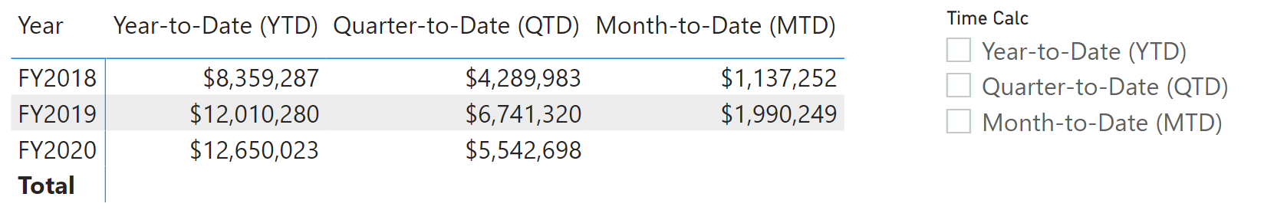
Without calculation groups, you need to create YTD, QTD, and MTD measures for each calculation you need, such as Total Sales, Profit, Target, and so on. Instead, create your visuals and add the calculation group and the other measures.
The dynamic and reusable nature of calculation groups makes them incredibly powerful to scale your semantic models.
Tip
See the documentation to learn more about how to Create calculations groups in Power BI.

Field parameters
Field parameters allow you to create interactive reports by enabling users to select different fields or measures dynamically. This feature is useful for creating customizable reports where users can choose the data they want to see.
In our scenario, we created a new parameter to include the Product, Category, and Color fields. Now we use our Total Sales measure and add the parameter in a visual instead of those individual fields. We also add a slicer with the parameter so users can switch between the selected fields. The following image shows a column chart for Total Sales by Category configured with the parameter in the X-axis and Total Sales in the Y-axis. A slicer is also present to dynamically switch between the Total Sales by Product, Category, and Color.
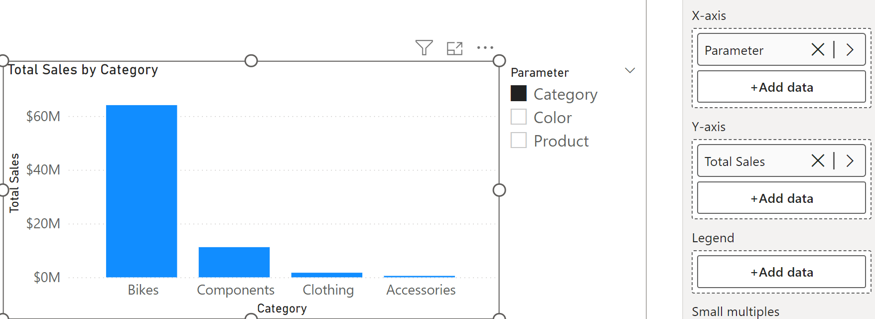
Before field parameters, report developers might create a visual for Total Sales by Product and repeat for Category and Color. Users could switch between the different visuals in a similar experience by overlaying the visuals on top of each other and adding bookmarks and buttons. However, the more visuals you add to a report page might affect performance.
Tip
See the documentation to learn more about how to Let report readers use field parameters to change visuals.

Dynamic format strings
Dynamic format strings let you adjust the format of a measure based on conditions, improving data readability and presentation.
Consider you want to display sales figures in different formats based on their value:
- Millions (M) for sales over 1,000,000.
- Thousands (K) for sales between 1,000 and 1,000,000.
- Exact value for sales under 1,000.
The following code uses the SWITCH function to apply the different formats based on the sales amount:
DAX
Total Sales with Format =
SWITCH(
TRUE(),
[Total Sales] > 1000000, FORMAT([Total Sales], "$#,##0,,M"),
[Total Sales] > 1000, FORMAT([Total Sales], "$#,##0,K"),
FORMAT([Total Sales], "$#,##0")
)
Dynamic format strings simplify your data presentation, reducing the need for multiple calculations or visuals, and can be used with calculation groups to reduce complexity and maintenance for your code.
Tip
See the documentation to learn more about how to Create dynamic format strings for measures.
- Optimization guide for Power BI
- Introduction to DAX

Optimize a model for performance in Power BI
- Review the performance of measures, relationships, and visuals.
- Use variables to improve performance and troubleshooting.
- Improve performance by reducing cardinality levels.
- Optimize DirectQuery models with table level storage.
- Create and manage aggregations.

Describe semantic model optimization techniques

Your design decisions should:
- Ensure that the correct data types are used.
- Remove unnecessary columns and rows.
- Avoid repeated values.
- Surface numeric columns as measures.
- Reduce column cardinality.
- Analyze model metadata.
- Summarize data where possible.

Review performance of measures, relationships, and visuals

To optimize performance, you must first identify where the source of the problem; in other words, find out which elements of your report and semantic model are causing the performance issues.

Identify report performance bottlenecks
To achieve optimal performance in your reports, you need to create an efficient semantic model that supports fast-running queries and measures. When you have a good foundation, you can improve the model further by analyzing the query plans and dependencies and then making changes to further optimize performance.
You should review the measures and queries in your semantic model to ensure that you are using the most efficient way to get the results that you want. Your starting point should be to identify bottlenecks that exist in the code. When you identify the slowest query in the semantic model, you can focus on the biggest bottleneck first and then establish a priority list to work through the other issues.

Analyze performance
You can use Performance Analyzer, which is a tool in Power BI Desktop, to help find out how each of your report elements is performing when users interact with them. For example, you can determine how long it takes for a particular visual to refresh when it's initiated by a user interaction. The tool will help you identify any elements that contribute to your performance issues, which can be useful during troubleshooting.
Before you run Performance Analyzer, to ensure you get the most accurate results in your analysis (test), make sure that you start with a clear visual cache and a clear data engine cache.
- Visual cache - When you load a visual, you can't clear this visual cache without closing Power BI Desktop and opening it again. To avoid any caching in play, you need to start your analysis with a clear visual cache.
To ensure that you have a clear visual cache, add a blank page to your Power BI Desktop file and then, with that page selected, save and then close the file. Reopen the Power BI Desktop file, which will open on the blank page.
- Data engine cache - When a query is run, the results are cached, so the results of your analysis will be misleading. You need to clear the data cache before rerunning the visual.
To clear the data cache, you can either restart Power BI Desktop or connect DAX Studio to the semantic model and then invoke the Clear Cache function.
When you have cleared the caches and opened the Power BI Desktop file on the blank page, go to the View ribbon tab, and then select Performance Analyzer.
To begin the analysis process, select Start recording, select the page of the report that you want to analyze, and then interact with the elements of the report that you want to monitor. You will see the results of your interactions displayed in the Performance Analyzer pane as you work. When you are finished, select the Stop button.
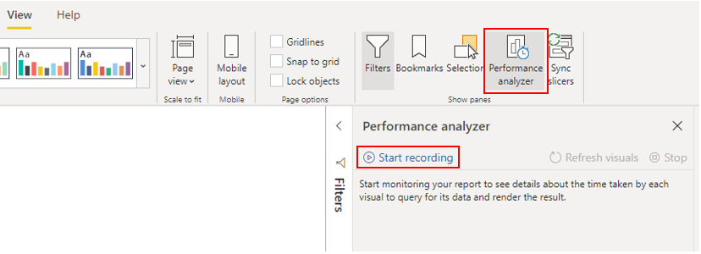
For more detailed information, see Use Performance Analyzer to examine report element performance.

Review results
You can review the results of your performance test in the Performance Analyzer pane. To review the tasks in order of duration, longest to shortest, right-click the Sort icon next to the Duration (ms) column header, and then select Total time in Descending order.
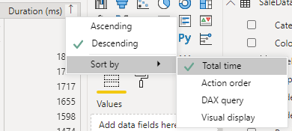
The log information for each visual shows how much time it took (duration) to complete the following categories of tasks:
- DAX query - The time it took for the visual to send the query, along with the time it took Power BI to return the results.
- Visual display - The time it took for the visual to render on the screen, including the time required to retrieve web images or geocoding.
- Other - The time it took the visual to prepare queries, wait for other visuals to complete, or perform other background processing tasks. If this category displays a long duration, the only real way to reduce this duration is to optimize DAX queries for other visuals, or reduce the number of visuals in the report.
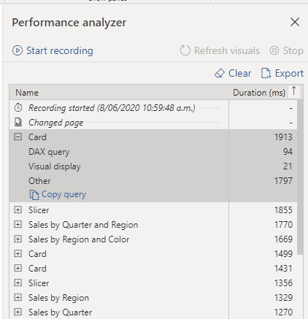
The results help you to understand the behavior of your semantic model and identify the elements that you need to optimize. You can compare the duration of each element in the report and identify the elements that have a long duration. You should focus on those elements and investigate why it takes them so long to load on the report page.
To analyze your queries in more detail, you can use DAX Studio, which is a free, open-source tool that's provided by another service.

Resolve issues and optimize performance

Visuals
If you identify visuals as the bottleneck leading to poor performance, you should find a way to improve performance with minimal impact to user experience.
Consider the number of visuals on the report page; fewer visuals means better performance. Ask yourself if a visual is really necessary and whether it adds value to the end user. If the answer is no, you should remove that visual. Rather than using multiple visuals on the page, consider other ways to provide additional details, such as drill-through pages or report page tooltips.
Examine the number of fields in each visual. The more visuals you have on the report, the higher chance for performance issues. In addition, the more visuals, the more the report can appear crowded and lose clarity. The upper limit for visuals is 100 fields (measures or columns), so a visual with more than 100 fields will be slow to load. Ask yourself whether you really need all of this data in a visual. You might find that you can reduce the number of fields that you currently use.

DAX query
When you examine the results in the Performance Analyzer pane, you can see how long it took the Power BI Desktop engine to evaluate each query (in milliseconds). A good starting point is any DAX query that's taking longer than 120 milliseconds. In this example, you identify one particular query that has a large duration time.
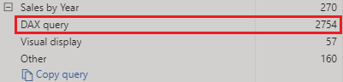
Performance Analyzer highlights potential issues, but it doesn't tell you what needs to be done to improve them. You might want to conduct further investigation into why this measure takes so long to process. You can use DAX Studio to investigate your queries in more detail.
For example, select Copy Query to copy the calculation formula onto the clipboard, then paste it into DAX Studio. You can then review the calculation step in more detail. In this example, you're trying to count the total number of products with order quantities greater than or equal to five.
DAX
Count Customers =
CALCULATE(
DISTINCTCOUNT(Order[ProductID]),
FILTER (Order, Order[OrderQty] >= 5)
)
After analyzing the query, you can use your own knowledge and experience to identify where the performance issues are. You can also try using different DAX functions to see whether they improve performance. In the following example, the FILTER function was replaced with the KEEPFILTER function. When the test was run again in Performance Analyzer, the duration was shorter as a result of the replaced function.
DAX
Count Customers =
CALCULATE(
DISTINCTCOUNT(Order[ProductID]),
KEEPFILTERS(Order[OrderQty] >= 5)
)
In this case, you can replace the FILTER function with the KEEPFILTER function to significantly reduce the evaluation duration time for this query. When you make this change, to check whether the duration time has improved or not, clear the data cache and then repeat the Performance Analyzer process.

Semantic model
If the duration of measures and visuals display low values (in other words they have a short duration time), they're not the reason for the performance issues. Instead, if the DAX query displays a high duration value, it's likely that a measure is written poorly or an issue has occurred with the semantic model. The issue might be caused by the relationships, columns, or metadata in your model, or it could be that the Auto date/time option is enabled, as described in the following section.

Relationships
You should review the model relationships between tables to ensure that you have established the correct relationships. Check that relationship cardinality properties are correctly set up. For example, a one-side column that contains unique values might be incorrectly configured as a many-side column. You'll learn more about how cardinality affects performance later in this module.

Columns
It's best practice to not import columns of data that you don't need. To avoid deleting columns in Power Query, you should try to deal with them at the source when loading data into Power BI Desktop. However, if it's impossible to remove redundant columns from the source query or the data has already been imported in its raw state, you can always use Power Query to examine each column. Ask yourself whether you really need each column and try to identify the benefit that each adds to your semantic model. If you find that a column adds no value, you should remove it from your semantic model. For example, suppose that you have an ID column with thousands of unique rows. You know that you won't use this particular column in a relationship, so it won't be used in a report. Therefore, you should conclude that this column as unnecessary and admit that it's wasting space in your semantic model.
When you remove an unnecessary column, you reduce the size of the semantic model which, in turn, results in a smaller file size and faster refresh time. Also, because the semantic model contains only relevant data, the overall report performance should improve.
For more information, see Data reduction techniques for Import modeling.

Metadata
Metadata is information about other data. Power BI metadata contains information on your semantic model, such as the name, data type and format of each of the columns, the schema of the database, the report design, when the file was last modified, the data refresh rates, and more.
When you load data into Power BI Desktop, it's good practice to analyze the corresponding metadata so you can identify any inconsistences with your semantic model and normalize the data before you start to build reports. Running analysis on your metadata should improve semantic model performance because, while analyzing your metadata, you'll possibly identify unnecessary columns, errors within your data, incorrect data types, the volume of data being loaded (large semantic models, including transactional or historic data, will take longer to load), and more.
You can use Power Query in Power BI Desktop to examine the columns, rows, and values of your source data. You can then use the available tools, such as those highlighted in the following image, to make the necessary changes.
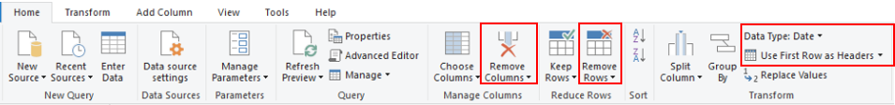
The Power Query options include:
- Unnecessary columns - Evaluates the need for each column. If one or more columns won't be used in the report and are therefore unnecessary, you should remove them by using the Remove Columns option.
- Unnecessary rows - Checks the first few rows in the semantic model to see whether they're empty or whether they contain data that you don't need in your reports; if so, it removes those rows by using the Remove Rows option.
- Data type - Evaluates the column data types to ensure that each one is correct. If you identify a data type that's incorrect, change it by selecting the column, selecting Data Type on the Transform ribbon tab, and then selecting the correct data type from the list.
- Query names - Examines the query (table) names in the Queries pane. Just like you did for column header names, you should change uncommon or unhelpful query names to names that are more obvious or names that the user is more familiar with. You can rename a query by right-clicking that query, selecting Rename, editing the name as required, and then pressing Enter.
- Column details - Power Query has the following three data preview options that you can use to analyze the metadata that's associated with your columns. You can find these options on the View ribbon tab, as shown in the following screenshot.
  - Column quality - Determines what percentage of items in the column are valid, have errors, or are empty. If the valid percentage is not 100 percent, you should investigate the reason, correct the errors, and populate empty values.
  - Column distribution - Displays frequency and distribution of the values in each of the columns. You'll investigate this further later in this module.
  - Column profile - Shows column statistics chart and a column distribution chart.
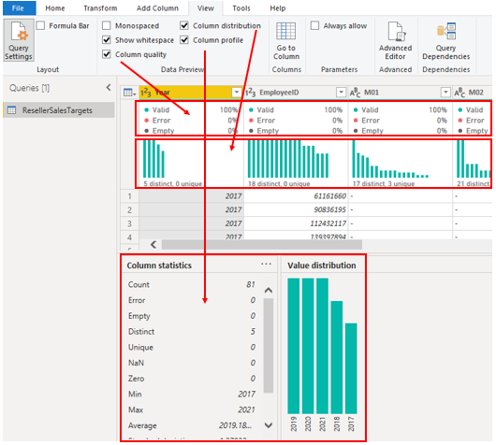
Note
If you're reviewing a query with more than 1,000 rows, and you want to analyze that whole semantic model, you need to change the default option at the bottom of the window. Select Column profiling based on top 1000 rows > Column profiling based on entire data set.
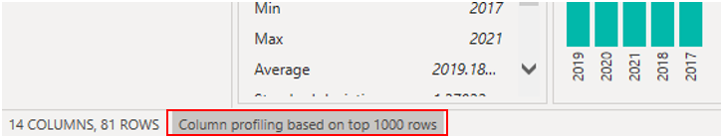
Other metadata that you should consider is the information about the semantic model as a whole, such as the file size and data refresh rates. You can find this metadata in the associated Power BI Desktop (.pbix) file. The data that you load into Power BI Desktop is compressed and stored to disk by the VertiPaq storage engine. The size of your semantic model has a direct impact on its performance; a smaller sized semantic model uses less resources (memory) and achieves faster data refresh, calculations, and rendering of visuals in reports.

Auto date/time feature
Another item to consider when optimizing performance is the Auto date/time option in Power BI Desktop. By default, this feature is enabled globally, which means that Power BI Desktop automatically creates a hidden calculated table for each date column, provided that certain conditions are met. The new, hidden tables are in addition to the tables that you already have in your semantic model.
The Auto date/time option allows you to work with time intelligence when filtering, grouping, and drilling down through calendar time periods. We recommend that you keep the Auto date/time option enabled only when you work with calendar time periods and when you have simplistic model requirements in relation to time.
If your data source already defines a date dimension table, that table should be used to consistently define time within your organization, and you should disable the global Auto date/time option. Disabling this option can lower the size of your semantic model and reduce the refresh time.
You can enable/disable the Auto date/time option globally so that it applies to all of your Power BI Desktop files, or you can enable/disable the option for the current file so that it applies only to an individual file.
To enable/disable the Auto date/time option, go to File > Options and settings > Options, and then select either the Global or Current File page. On either page, select Data Load and then, in the Time Intelligence section, select or clear the check box as required.
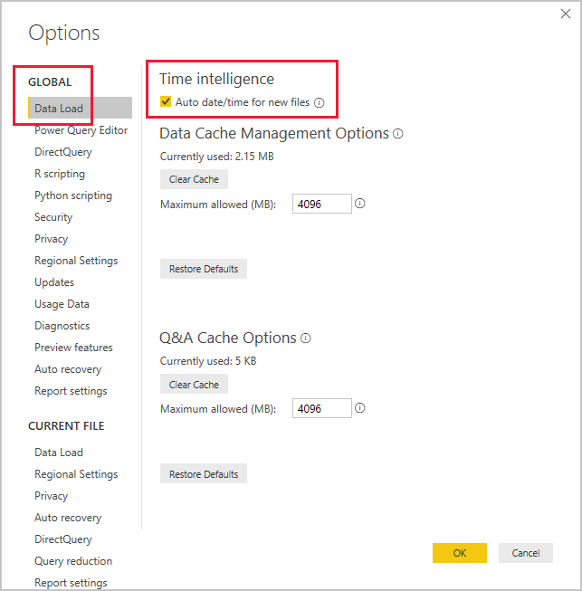
For an overview and general introduction to the Auto date/time feature, see Apply auto date/time in Power BI Desktop.

Use variables to improve performance and troubleshooting
You can use variables in your DAX formulas to help you write less complex and more efficient calculations. Variables are underused by developers who are starting out in Power BI Desktop, but they're effective and you should use them by whenever you can.
Some expressions involve the use of many nested functions and the reuse of expression logic. These expressions take a longer time to process and are difficult to read and, therefore, troubleshoot. If you use variables, you can save query processing time. This change is a step in the right direction toward optimizing the performance of a semantic model.
The use of variables in your semantic model provides the following advantages:
- Improved performance - Variables can make measures more efficient because they remove the need for Power BI to evaluate the same expression multiple times. You can achieve the same results in a query in about half the original processing time.
- Improved readability - Variables have short, self-describing names and are used in place of an ambiguous, multi-worded expression. You might find it easier to read and understand the formulas when variables are used.
- Simplified debugging - You can use variables to debug a formula and test expressions, which can be helpful during troubleshooting.
- Reduced complexity - Variables don't require the use of EARLIER or EARLIEST functions, which are difficult to understand. These functions were required before variables were introduced, and were written in complex expressions that introduced new filter contexts. Now that you can use variables instead of those functions, you can write fewer complex formulas.

Use variables to improve performance
To illustrate how you can use a variable to make a measure more efficient, the following table displays a measure definition in two different ways. Notice that the formula repeats the expression that calculates "same period last year" but in two different ways: the first instance uses the normal DAX calculation method and the second one uses variables in the calculation.
The second row of the table shows the improved measure definition. This definition uses the VAR keyword to introduce a variable named SalesPriorYear, and it uses an expression to assign the "same period last year" result to that new variable. It then uses the variable twice in the DIVIDE function.
Without variable
DAX
Sales YoY Growth =
DIVIDE(
([Sales] - CALCULATE([Sales], PARALLELPERIOD('Date'[Date], -12, MONTH))),
CALCULATE([Sales], PARALLELPERIOD('Date'[Date], -12, MONTH))
)
With variable
DAX
Sales YoY Growth =
VAR SalesPriorYear =
CALCULATE([Sales], PARALLELPERIOD('Date'[Date], -12, MONTH))
VAR SalesVariance =
DIVIDE(([Sales] - SalesPriorYear), SalesPriorYear)
RETURN
SalesVariance
In the first measure definition, the formula is inefficient because it requires Power BI to evaluate the same expression twice. The second definition is more efficient because, thanks to the variable, Power BI only needs to evaluate the PARALLELPERIOD function once.
If your semantic model has multiple queries with multiple measures, the use of variables could reduce the overall query processing time in half and improve the overall performance of the semantic model. Furthermore, this solution is a simple one; imagine the savings as the formulas get more complicated, for instance, when you are working with percentages and running totals.

Use variables to improve readability
In addition to improved performance, you might notice how the use of variables makes your code simpler to read.
When using variables, it's best practice to use descriptive names for the variables. In the previous example, the variable is named SalesPriorYear, which clearly states what the variable is calculating. Consider the outcome of using a variable that was named X, temp or variable1; the purpose of the variable would not be clear at all.
Using clear, concise, meaningful names will help make it easier for you to understand and document what you're calculating, and it's much simpler for other developers to maintain in the future.

Use variables to troubleshoot multiple steps
You can use variables to help you debug a formula and identify what the issue is. Variables help simplify the task of troubleshooting your DAX calculation by evaluating each variable separately and by recalling them in the RETURN clause.
In the following example, you test an expression that's assigned to a variable. In order to debug you temporarily rewrite the RETURN clause to return the variable. The measure definition returns only the SalesPriorYear variable because that's what comes after the RETURN expression.
DAX
Sales YoY Growth % =
VAR SalesPriorYear = CALCULATE([Sales], PARALLELPERIOD('Date'[Date], -12, MONTH))
VAR SalesPriorYear% = DIVIDE(([Sales] - SalesPriorYear), SalesPriorYear)
RETURN SalesPriorYear%
The RETURN clause returns only the SalesPriorYear% variable. This technique allows you to revert the expression when you have completed the debugging. It also makes calculations simpler to understand due to reduced complexity of the DAX code.

Reduce cardinality
Completed100 XP
- 7 minutes
Cardinality is a term that's used to describe the uniqueness of the values in a column. Cardinality is also used in the context of model relationships, where it describes the direction of the relationship.

Identify cardinality levels in columns
Previously, when you used Power Query to analyze the metadata, the Column distribution option on the View ribbon tab displayed statistics on how many distinct and unique items were in each column in the data.
- Distinct values count - The total number of different values found in a given column.
- Unique values count - The total number of values that only appear once in a given column.
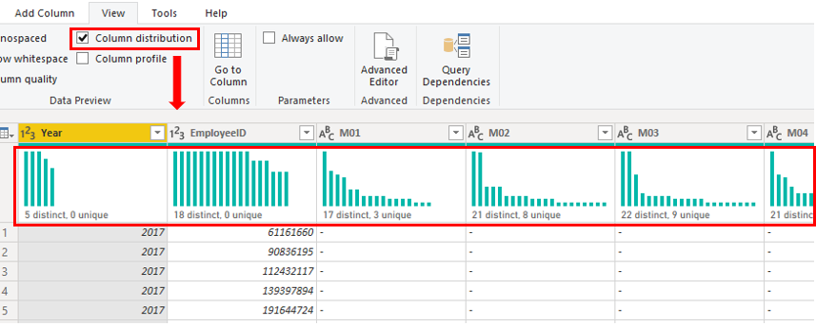
A column that has many repeated values in its range (unique count is low) has a low level of cardinality. Conversely, a column that has many unique values in its range (unique count is high) has a high level of cardinality.
Lower cardinality leads to more optimized performance, so you should try to reduce the number of high cardinally columns in your semantic model.

Reduce relationship cardinality
When you import multiple tables, it's possible that you'll do some analysis by using data from all those tables. Relationships between those tables are necessary to accurately calculate results and display the correct information in your reports. Power BI Desktop helps make creating those relationships easier. In fact, in most cases, you won't need to do anything because the autodetect feature can do it for you. However, you might occasionally need to create relationships or make changes to a relationship. Regardless, it's important to understand relationships in Power BI Desktop and how to create and edit them.
When you create or edit a relationship, you can configure other options. By default, Power BI Desktop automatically configures other options based on its assessment of the model data, which can be different for each relationship based on the data in the columns.
The relationships can have different cardinality. Cardinality is the direction of the relationship, and each model relationship must be defined with a cardinality type. The cardinality options in Power BI are:
- Many-to-one (*:1) - This relationship is the most common. It means that the column in one table can have more than one instance of a value, and the other related table, often known as the lookup table, has only one instance of a value.
- One-to-one (1:1) - The column in one table has only one instance of a particular value, and the other related table has only one instance of a particular value.
- One-to-many (1:*) - The column in one table has only one instance of a particular value, and the other related table can have more than one instance of a value.
- Many-to-many (*:*) - With composite models, you can establish a many-to-many relationship between tables, which removes requirements for unique values in tables. It also removes previous workarounds, such as introducing new tables only to establish relationships.
During development, you create and edit relationships in your model, so when you're building new relationships in your model, regardless of what cardinality you have chosen, always ensure that both of the columns that you are using to participate in a relationship have the same data type. Your model will never work if you try to build a relationship between two columns, where one column has a text data type and another column has an integer data type.
In the following example, the ProductID column has the Whole number data type in both the Product and Sales tables. The columns with data type Integer perform better than columns with data type Text.
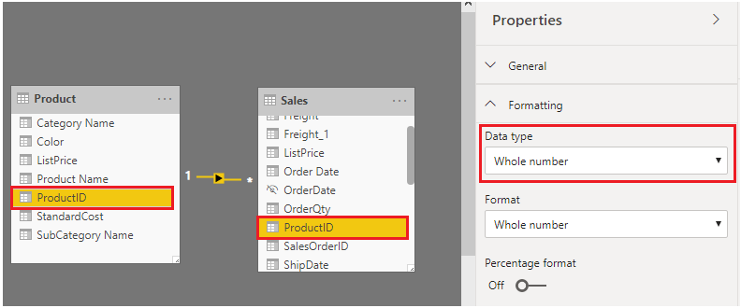

Improve performance by reducing cardinality levels
Power BI Desktop offers different techniques that you can use to help reduce the data that's loaded into semantic models, such as summarization. Reducing the data that's loaded into your model improves the relationship cardinality of the report. For this reason, it's important that you strive to minimize the data that's loaded into your models. That's especially true for large models, or models that you anticipate will grow to become large over time.
Perhaps the most effective technique to reduce a model size is to use a summary table from the data source. Where a detail table might contain every transaction, a summary table might contain one record per day, per week, or per month. It might be a sum of all of the transaction amounts per day, for instance.
For example, a source sales fact table stores one row for each order line. Significant data reduction could be achieved by summarizing all sales metrics when you group by date, customer, and product, and individual transaction detail isn't needed.
Consider, then, that you can achieve an even more significant data reduction by summarizing at month level. It could achieve a possible 99 percent reduction in model size; but, reporting at day level or an individual order level is no longer possible. Deciding to summarize fact data always involves a tradeoff with the detail of your data. A disadvantage is that you might lose the ability to drill into data because the detail no longer exists. This tradeoff could be mitigated by using a Composite model.
In Power BI Desktop, a Composite model allows you to determine a storage mode for each table. Therefore, each table can have its Storage Mode property set as Import or DirectQuery.
An effective technique to reduce the model size is to set the Storage Mode property for larger fact tables to DirectQuery. This design approach can work well in conjunction with techniques that are used to summarize your data. For example, the summarized sales data could be used to achieve high performance "summary" reporting. You could then create a drillthrough page to display granular sales for a specific (and narrow) filter context, displaying all in-context sales orders. The drillthrough page could include visuals based on a DirectQuery table to retrieve the sales order data (sales order details).
For more information, see Data reduction techniques for Import modeling.

Optimize DirectQuery models with table level storage
Completed100 XP
- 18 minutes
DirectQuery is a storage mode where Power BI connects directly to the data source. It is an alternative to importing data into model tables.
When you use the DirectQuery storage mode, query response times depend heavily on the performance of the underlying data source. Slow query response times lead to a negative user experience and, in the worst-case scenarios, queries might time out. Also, the number of users who are opening the reports at any one time impact the load that's placed on the data source. For example, if a report page has 20 visuals and 10 people opening that page, 200 queries (or more) will be sent to the data source because each visual will issue one or more queries.
Unfortunately, the performance of your semantic model is not only impacted by the performance of the underlying data source, but also by other uncontrollable factors, such as:
- Network latency; faster networks return data quicker.
- The performance of the data source's server and how many other workloads are on that server. For example, consider the implications of a server refresh taking place while hundreds of people are using the same server for different reasons.
Therefore, using DirectQuery poses a risk to the quality of your model's performance. To optimize performance in this situation, you need to have control over, or access to, the source database.
For more detailed information, see DirectQuery model guidance in Power BI Desktop.

Implications of using DirectQuery
It's best practice to import data into your model tables, but your organization might need to use the DirectQuery storage mode because of one of the following reasons (benefits of DirectQuery):
- It's suitable in cases where data changes frequently and near real-time reporting is required.
- It can handle large data without the need to pre-aggregate.
- It applies data sovereignty restrictions to comply with legal requirements.
- It can be used with a multidimensional data source that contains measures such as SAP Business Warehouse (BW).
If your organization wants to use DirectQuery, you should clearly understand its behavior and be aware of its limitations. You will then be in a good position to take action to optimize the DirectQuery model as much as possible.

Behavior of DirectQuery connections
When you use DirectQuery to connect to data in Power BI Desktop, that connection behaves in the following way:
- When you initially use the Get Data feature in Power BI Desktop, you will select the source. If you connect to a relational source, you can select a set of tables and each one will define a query that logically returns a set of data. If you select a multidimensional source, such as SAP BW, you can only select the source.
- When you load the data, no data is imported into the Power BI Desktop, only the schema is loaded. When you add a visual to a report, queries are sent to the underlying source to retrieve the necessary data. The time it takes to refresh the visual depends on the performance of the underlying data source.
- If changes are made to the underlying data, they won't be immediately reflected in the existing visuals due to caching. You need to carry out a refresh to see those changes. The necessary queries are present for each visual, and the visuals are updated accordingly.
- When you publish the Power BI Desktop file to the Power BI service, it publishes a semantic model. However, no data is included with that semantic model.
- When you open an existing report in Power BI service (or build a new one), the underlying source is again queried to retrieve the necessary data. Depending on the location of the original source, you might have to configure an on-premises data gateway.
- You can pin visuals, or entire report pages, as dashboard tiles. The tiles are automatically refreshed on a schedule, for example, every hour. You can control the frequency of this refresh to meet your requirements. When you open a dashboard, the tiles reflect the data at the time of the last refresh and might not include the latest changes that are made to the underlying data source. You can always refresh an open dashboard to ensure that it's up to date.

Limitations of DirectQuery connections
The use of DirectQuery can have negative implications. The limitations vary, depending on the specific data source that is being used. You should take the following points into consideration:
- Performance - As previously discussed, your overall user experience depends heavily on the performance of the underlying data source.
- Security - If you use multiple data sources in a DirectQuery model, it's important to understand how data moves between the underlying data sources and the associated security implications. You should also identify whether security rules are applicable to the data in your underlying source because, in Power BI, every user can see that data.
- Data transformation - Compared to imported data, data that is sourced from DirectQuery has limitations when it comes to applying data transformation techniques with Power Query. For example, if you connect to an OLAP source, such as SAP BW, you can't make any transformations at all; the entire external model is taken from the data source. If you want to make any transformations to the data, you will need to do so in the underlying data source.
- Modeling - Some of the modeling capabilities that you have with imported data aren't available, or are limited.
- Reporting - Almost all the reporting capabilities that you have with imported data are also supported for DirectQuery models, provided that the underlying source offers a suitable level of performance.
For more detailed information on the limitations of using DirectQuery, see Implications of using DirectQuery.
Now that you have an understanding of how DirectQuery works and its limitations, you can take action to improve the performance.

Optimize performance
Continuing with the Tailwind Traders scenario, during your review of the semantic model, you discover that the model uses DirectQuery to connect to source data. This use of DirectQuery is the reason why users are experiencing poor report performance. It's taking too long to load the pages in the report, and tables are not refreshing quickly enough when certain selections are made. You need to take action to optimize the performance of the DirectQuery model.
You can examine the queries that are being sent to the underlying source and try to identify the reason for the poor query performance. You can then make changes in Power BI Desktop and the underlying data source to optimize overall performance.

Optimize data in Power BI Desktop
When you've optimized the data source as much as possible, you can take further action within Power BI Desktop by using Performance Analyzer, where you can isolate queries to validate query plans.
You can analyze the duration of the queries that are being sent to the underlying source to identify the queries that are taking a long time to load. In other words, you can identify where bottlenecks exist.
You don't need to use a special approach when optimizing a DirectQuery model; you can apply the same optimization techniques that you use to tune imported data. For example, you can reduce the number of visuals on the report page or reduce the number of fields that are used in a visual. You can also remove unnecessary columns and rows.
For more detailed guidance on how to optimize a DirectQuery query, see: DirectQuery model guidance in Power BI Desktop and Guidance for using DirectQuery successfully.

Optimize the underlying data source (connected database)
Your first stop is the data source. You need to tune the source database as much as possible because anything you do to improve the performance of that source database will in turn improve Power BI DirectQuery. The actions that you take in the database will do the most good.
Consider the use of the following standard database practices that apply to most situations:
- Avoid the use of complex calculated columns because the calculation expression will be embedded into the source queries. It's more efficient to push the expression back to the source because it avoids the push down. You could also consider adding surrogate key columns to dimension tables.
- Review source table indexes and verify that the current indexing is optimal. If you need to create new indexes, ensure that they're appropriate.
Refer to the guidance documents of your data source and implement their performance recommendations.

Customize the Query reduction options
Power BI Desktop gives you the option to send fewer queries and to disable certain interactions that will result in a poor experience when the resulting queries take a long time to run. Applying these options prevents queries from continuously hitting the data source, which should improve performance.
In this example, you edit the default settings to apply the available data reduction options to your report. You access the settings by selecting File > Options and settings > Options, scrolling down the page, and then selecting the Query reduction option.
The following query reduction options are available:
- Reduce number of queries sent by - By default, every visual interacts with every other visual. Selecting this check box disables that default interaction. You can then choose which visuals interact with each other by using the Edit interactions feature.
- Slicers - By default, the Instantly apply slicer changes option is selected. To force the report users to manually apply slicer changes, select the Add an apply button to each slicer to apply changes when you're ready option.
- Filters - By default, the Instantly apply basic filter changes option is selected. To force the report users to manually apply filter changes, select one of the alternative options:
  - Add an apply button to all basic filters to apply changes when you're ready
  - Add a single apply button to the filter pane to apply changes at once (preview)
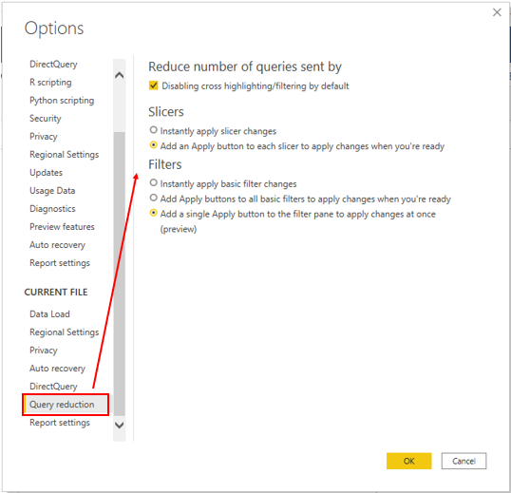

Create and manage aggregations
Completed100 XP
- 7 minutes
When aggregating data, you summarize that data and present it in at a higher level of granularity. For example, you can summarize sales data and group it by date, customer, product, and so on. The aggregation process reduces the table sizes in the semantic model, allowing you to focus on important data and helping to improve the query performance.
Your organization might decide to use aggregations in their semantic models for the following reasons:
- You work with large volumes of data. In this case, aggregations provide better query performance and help you analyze and reveal the insights over this large data. Aggregated data is cached and, therefore, uses a fraction of the resources that are required for detailed data.
- You experience a slow data refresh. In this case, aggregations help to speed up the refresh process. The smaller cache size reduces the refresh time, so data gets to users faster. Instead of refreshing what could be millions of rows, you refresh a smaller amount of data instead.
- You have a large semantic model. In this case, aggregations help to reduce and maintain the size of your model.
- You anticipate future growth of your semantic model. In this case, you can use aggregations as a proactive step toward future proofing your semantic model by lessening the potential for performance and refresh issues and overall query problems.
Continuing with the Tailwind Traders scenario, you have taken several steps to optimize the performance of the semantic model, but the IT team has informed you that the file size is still too large. The file size is currently 1 gigabyte (GB), so you need to reduce it to around 50 megabytes (MB). During your performance review, you identified that the previous developer didn't use aggregations in the semantic model, so you now want to create aggregations for the sales data to reduce the file size and further optimize the performance.

Create aggregations
Before you create aggregations, you should decide on the level of granularity on which you want to create them. In this example, you want to aggregate the sales data at the day level.
When you decide on the grain, the next step is to decide on how you want to create the aggregations. You can create aggregations in different ways and each method will yield the same results, for example:
- If you have access to the database, you can create a table (or view) and then import it into Power BI Desktop.
- In Power BI Desktop, you can use Power Query to create the aggregations step-by-step.
In this example, you open a query in Power Query and notice that the data has not been aggregated; it has over 999 rows, as illustrated the following screenshot.
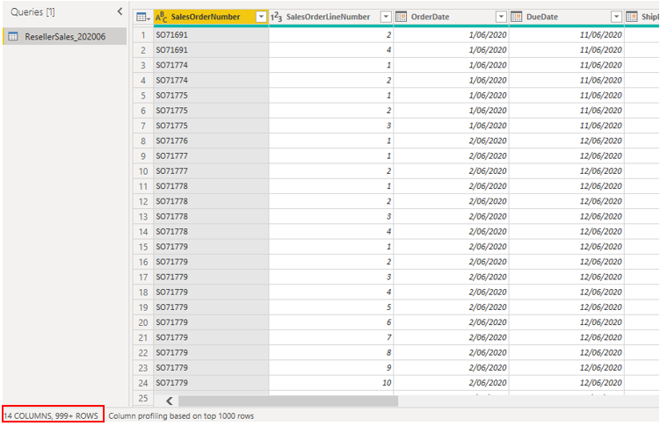
You want to group by the OrderDate column and summarize the OrderQuantity and SalesAmount columns. Start by selecting Choose Columns on the Home ribbon tab. In the window that opens, select the columns that you want in the aggregation, and then select OK.
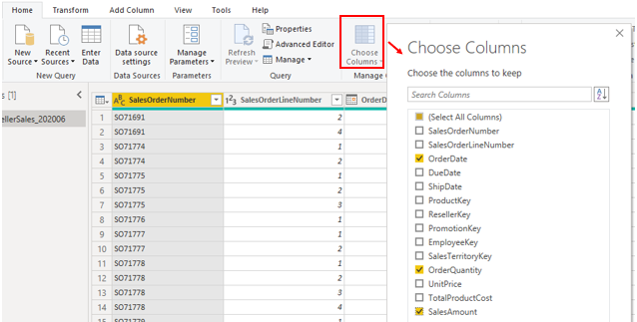
When the selected columns display on the page, select the Group By option on the Home ribbon tab. In the window that opens, select the column that you want to group by (OrderDate) and enter a name for the new column (OnlineOrdersCount).
Select the Advanced option, and then select the Add aggregation button to configure another column row. Enter a name for the aggregation column, select the operation of the column, and then select the column to which you want to link the aggregation. Repeat these steps until you have added all the aggregations, and then select OK.
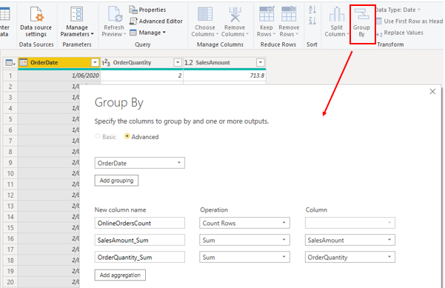
It might take a few minutes for a preview of your aggregation to display, but when it does, you'll see how the data has been transformed. The data will be aggregated into each date, and you will be able to see the values for the orders count and the respective sum of the sales amount and order quantity.
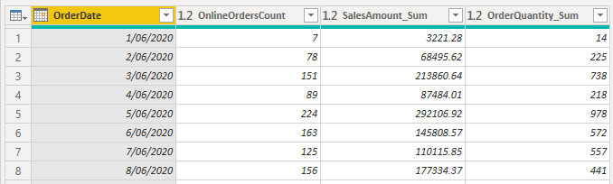
Select the Close and Apply button to close Power Query Editor and apply the changes to your semantic model. In Power BI Desktop, on the Home ribbon tab, select Refresh. Observe the screen because a brief message will display the number of rows that your semantic model has loaded. This number of rows should be significantly less than the number that you started with. You can also see this number when you open Power Query Editor again, as illustrated in the following screenshot. In this example, the number of rows was reduced to 30.
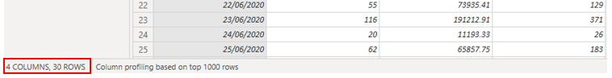
Remember, you started with 999+ rows. Using aggregation has significantly reduced the number of rows in your semantic model, which means that Power BI has less data to refresh and your model should perform better.

Manage aggregations
You can later manage aggregations in Power BI Desktop to make changes to their behavior, if required.
You can open the Manage Aggregations window from any view in Power BI Desktop. In the Data pane, right-click the table and then select Manage aggregations.
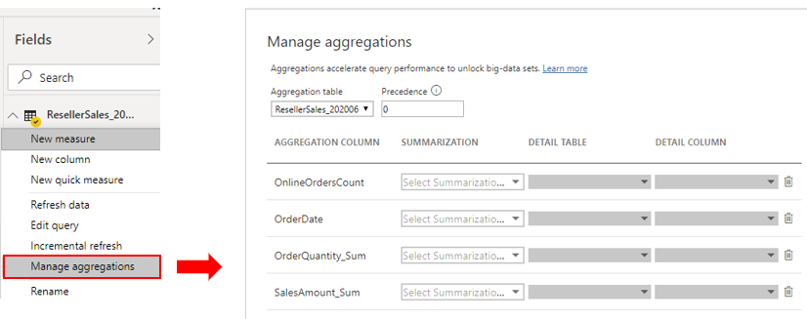
For each aggregation column, you can select an option from the Summarization dropdown list and make changes to the selected detail table and column. When you are finished managing the aggregations, select Apply All.
For more detailed information on how to create and manage aggregations, see Use aggregations in Power BI Desktop.

Create and manage Power BI assets

Learning objectives
Upon completion of this module, you should be able to:
- Create core and specialized semantic models.
- Create Power BI Template and Power BI Project files.
- Use lineage view and endorse data assets in Power BI service.
- Use XMLA endpoint to connect semantic models.

With Power BI, you can divide the data across multiple specialized semantic models all "chained" to a core semantic model, which gives separate regions flexibility and reduce the performance impact across reports overall. Now that you have semantic models referencing other semantic models, you can use lineage view in Power BI service to explore relationships. If you're working on your semantic models with external tools, you can also use the XMLA endpoint to connect and manage semantic models.
In this module, we’ll show you how to:
- Create and connect to core and specialized semantic models.
- Create Power BI template .pbit files.
- Track and manage report development with Power BI Project files.
- Explore the relationships between data sources, semantic models, and reports.
- Connect and manage semantic models through XMLA endpoint.

Create reusable Power BI assets
Completed100 XP
- 8 minutes
When you were first introduced to Power BI, you probably learned how to get data from various sources such as SQL Server databases, Excel files, and even text files. Creating the same or similar semantic model for each report is tedious work. Further, if others also want to develop reports on that exact semantic model, what's your process for sharing?

Create reusable core assets
Assets can mean semantic models, dataflows, reports, and dashboards, and we most commonly mean semantic models in this module. In our previous example, you spent precious time curating the perfect semantic model, and now you can share and reuse it. Before creating visuals, publish the file to Power BI service and effectively create a core semantic model.
Next time someone needs to create a report on that semantic model, they can connect to a Power BI semantic model from Power BI Desktop. If you publish to a shared location, it allows peers to use the same semantic model. A single shared semantic model protects data integrity. This trustworthy semantic model also prevents orphaned semantic models when someone recreates a report without deleting the earlier copies. As an enterprise data analyst, it's your responsibility to be a good data steward to encourage the democratization of data rather than disparate copies of data with questionable quality.
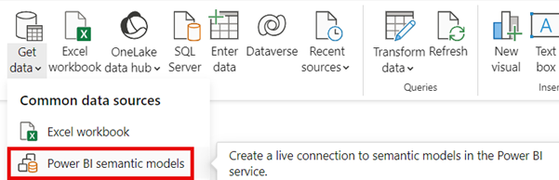

Create specialized semantic models
In our introduction example, we recognized the need to reduce report size and provide targeted reports across regions. To meet these goals, we can create specialized semantic models. Consider creating a new semantic model with the specific regional data, instead of limiting regional users access to a single global report.
To create a specialized semantic model, open a new Power BI Desktop instance and connect to the core semantic model. You're now connected live to that semantic model, which doesn't allow any changes to the model, but you can filter and visualize data. Use the Make changes to the model option to switch from a live connection to DirectQuery.
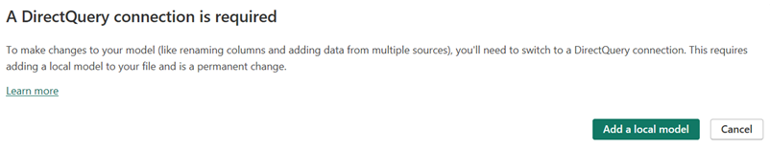
In the following screenshot, there are three tables from the connected semantic model and two new tables added. You can add measures, calculation groups, and more.
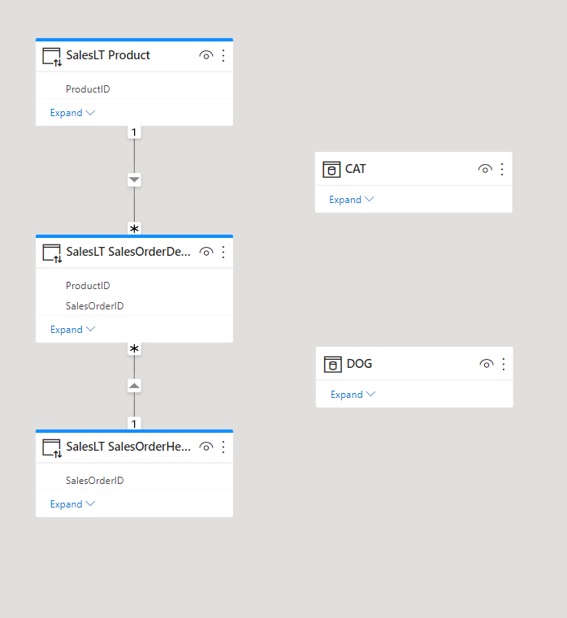
Note
You need a data gateway configured to support the DirectQuery model if you want to make changes to the underlying semantic model. For more information, see What is an on-premises data gateway documentation.

Power BI Template files
Power BI Template .pbit files allow you to save a report to reuse or share for different purposes. These template files are highly customizable, depending on your needs. When you saved a template file, it has all of the same information as if you saved a traditional .pbix file.
You can create a standardized report design template. Consider your organization is getting started with Power BI and users are still learning how to interact with reports. As an example, you can create a template with a header for title, description, and location for applicable slicers. You can now save and close the template, and then open the template to start creating your new report. If you have a report that already has your desired format, you can also remove all data sources and save it so only the theme and visual configurations are stored.
You can also use a template as a starting point for future reports or as a gold copy to preserve the state before modifying the report. In this scenario, you can create the entire report, then save as a template as an extra copy of the file. While it's not recommended to use a template file for version control, it might be helpful when you're still developing a report or are collaborating on the report and want a backup. Since Power BI templates open as an unsaved file, any changes made wouldn't affect the template file unless you specifically save and overwrite the template file.
Note
For more information, see the Create and use report templates in Power BI Desktop documentation.

Manage development lifecycle for Power BI assets
Completed100 XP
- 11 minutes
Lifecycle management refers to the process of tracking and managing each stage of the development process. The Power BI report development process includes creating reusable assets and deciding how to handle changes to your semantic models and reports.
Traditional Power BI .pbix files store the semantic model and report in a single binary file, which doesn't allow granular tracking with source control. Power BI Project files, in combination with code editors and source control systems, allow you to track versions and manage code deployments as part of a Continuous Integration Continuous Delivery (CI/CD) system.

Create a Power BI Project file
Power BI Project files store your semantic model and report in individual plain text files for use with code editors and source control solutions. There are many benefits to using Power BI projects to track and manage your report development:
- Text editor support: Item definition files are JSON formatted text files containing semantic model and report metadata.
- Source control: Power BI semantic model and report item definitions can be stored in a source control system, like Git.
These files can be used in a code editor like Microsoft Visual Studio Code (VS Code) to support Git integration. When you save your work as a Power BI Project (.pbip), the report and semantic model item definitions are saved as individual plain text files in a simple, intuitive folder structure.
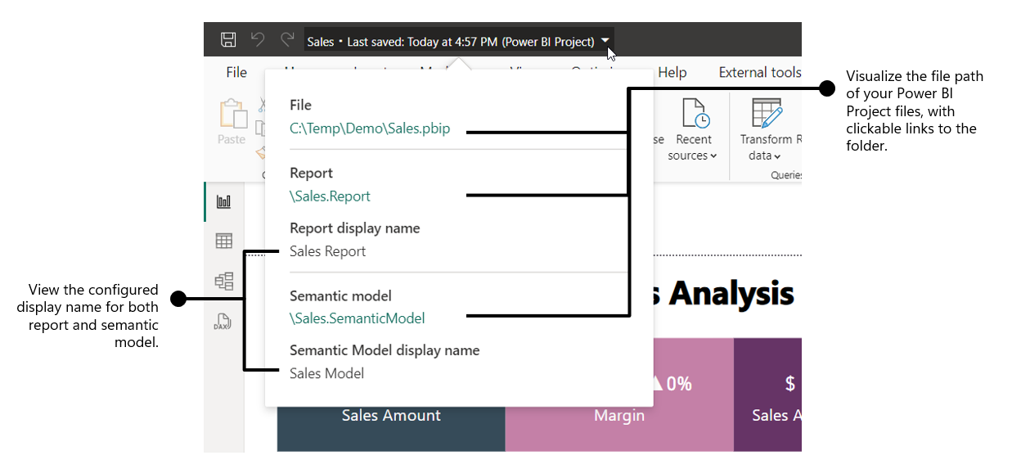

Power BI Project structure
When you create a Power BI Project, all of the metadata is stored in flat files. As shown in the earlier screenshot, there are separate folders for the semantic model and the report. This separation might feel familiar if you've published reports to the Power BI service before.
- The semantic model folder stores all of the data stored in a semantic model, including relationships, measures, and transformations.
- The report folder stores all of the data for the visuals and report pages, including custom visuals and mobile layout.
Existing Projects use TMSL (Tabular Model Scripting Language), which stores the data in a single model.bim file. You can enable and upgrade your Project to use TMDL (Tabular Model Definition Language), which stores the metadata in individual files. Power BI Projects are in preview and you might have a different folder structure if you don't have all preview features enabled.
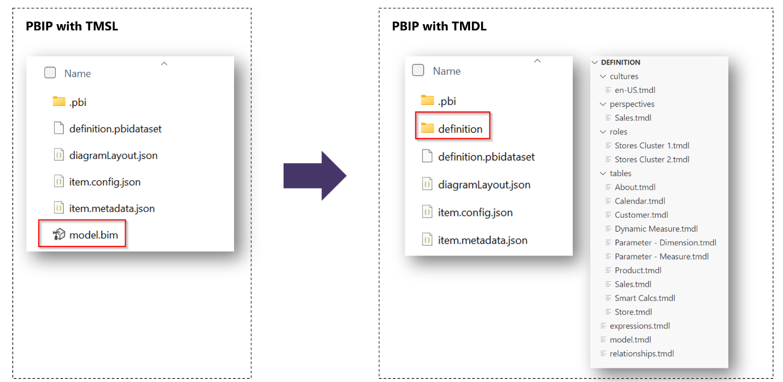
The following screenshot shows the definition folder within the Project Report folder. The definition folder is available with the Enhanced .pbir (Power BI Report) format.
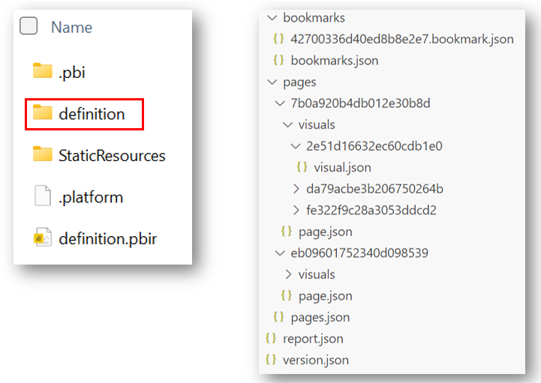
Note
See the Power BI Desktop projects (PREVIEW) documentation for full details and considerations and limitations.

Track and manage with Projects
Power BI .pbix files are binary and changes aren't visible in code editors. When changes are made to a file, you don't know if it's in the semantic model or visuals without reviewing the entire report and semantic model. When you use a Power BI .pbip file, you can continue to develop your report in Power BI Desktop and have a trackable record to review if a report isn't behaving as expected.
Let's expand on our example with a core semantic model and specialized semantic models for different regions. Consider your team stores Power BI files in OneDrive to have version control. You were informed that one of the custom regional reports isn't displaying accurate numbers and begin to investigate. You need to open either an older copy of the file or one of the other regional files and review them entirely to find the difference.
In comparison, if you have a Power BI Project and also use source control, such as Git, then you can review changes through previous pull requests to quickly see the change. Once you identify the change, you can compare it to the other file and make the necessary fix.
In the following screenshot, you can see a difference in the measure where a single value 6 was changed to 7 by mistake. This example uses VS Code and Git to see the difference in the code and version history of previous changes.
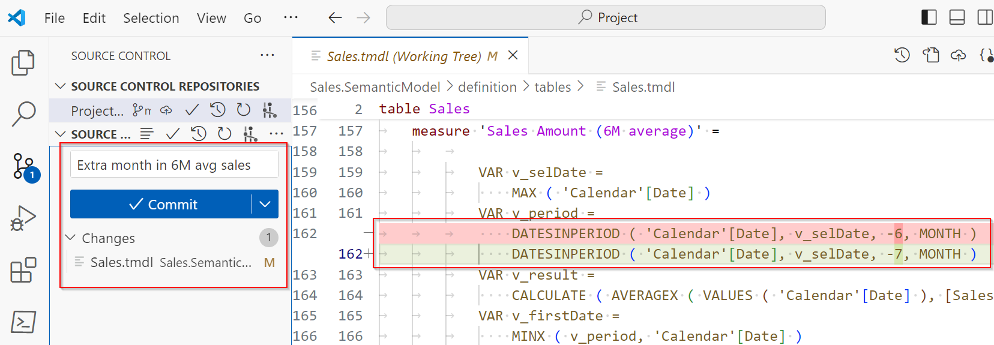

Continuous Integration and Continuous Delivery (CI/CD)
Many organizations use CI/CD systems to propose and validate changes during development before releasing them to production. A common system design has different stages to perform checks between Development and Test environments before deploying to Production.
In the Power BI service, you can use Deployment pipelines to create different workspaces that match your stages. Once you have your pipeline and workspaces configured, when you make changes in Development, you can see the difference between Test before deploying the changes. The following screenshot shows how the changes between the stages are visually represented.
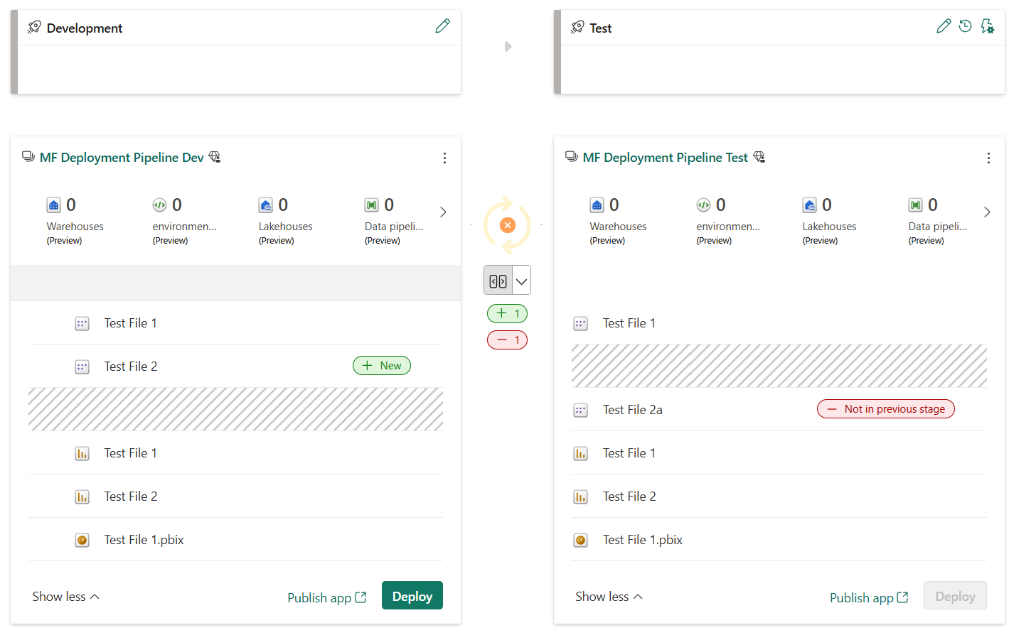
Note
Deployment pipelines require each workspace to be assigned to a Premium or Fabric capacity. You can also track differences between other Fabric items in workspaces, if you are using them.
CI/CD systems also typically use source control to track and manage changes. This version control with Power BI Project files is possible through Git integration. Git integration in VS Code enables developers working with Power BI Desktop projects to streamline development processes, source control, and collaboration with Git repositories. With Git integration, you can:
- Backup and version your work.
- Revert to previous states.
- Collaborate with others or work alone using Git branches.
- Use the capabilities of familiar source control tools, like Azure DevOps.
In the following screenshot, you can see the Azure DevOps repo (repository) with files in the main branch. Developers can clone this repo, create their own development branches, and then create pull requests to merge into main. This development process allows collaboration on the same content without losing work.

Considerations
This unit provides an overview of what's possible using Power BI Projects and how to combine them with Git integration and Deployment pipelines. Each organization has different requirements and you can use this content to help understand how to use these tools for your needs.
Tip
See the Introduction to the CI/CD process as part of the ALM cycle in Microsoft Fabric documentation for in-depth scenarios and possibilities.

Use lineage view and endorse data assets
Completed100 XP
- 7 minutes
We covered how to create core and specialized Power BI semantic models and templates to distribute within the organization. Now report developers can connect directly to those curated semantic models, but might be unsure which semantic models and other items should be used. Chained semantic models can also present a problem if report developers don't know what data source or core semantic model relates to a report. You can solve both of these issues in the Power BI service with Endorsement and Lineage view.

Endorse semantic models
Users can discover other semantic models in the Power BI service and build their own reports. You can use this feature and make it easier for collaboration through Endorsement. Endorsement helps users find high-quality content they need by identifying the content as verified and trustworthy.
Items can receive one of three endorsement badges - Promoted, Certified, or Master data:
- Promoted means that the item creators think the item is ready for sharing and reuse. Any user with write permissions on an item can promote it.
- Certified means that an organization-authorized reviewer has certified that the item meets the organization's quality standards, can be regarded as reliable and authoritative, and is ready for use across the organization.
- Master data means the data in the item is a core source of organizational data. The master data designation might be used to indicate a single source of truth for certain kinds of data, such as product codes or customer lists.
See the following screenshot of the Endorsement and discovery section in the semantic model settings. For both Certified and Master data, there are links to help you know how to get your data certified or endorsed as master data. These links are configured by an administrator for your organization. Also note the option to make the item discoverable or not.
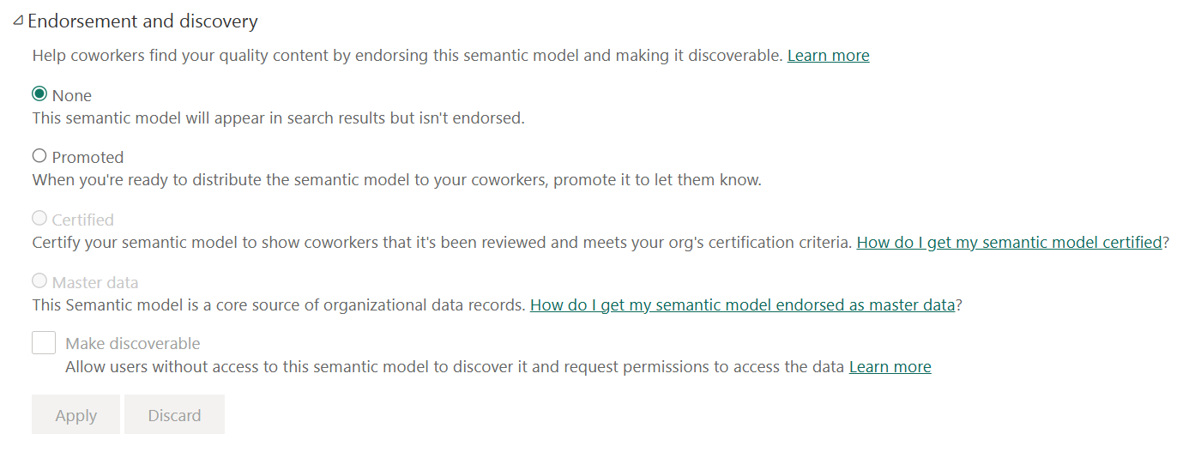
Note
Power BI is also an experience in Microsoft Fabric and endorsement can be applied to all Power BI and Fabric items, except Power BI Dashboards. See more in the Endorsement overview documentation.

Explore with Lineage view
Lineage view in a Power BI workspace allows you to view dependencies between the different workspace items. An example would be seeing underlying data sources for a semantic model and the final report all connected by lines.
In the following screenshot, we explore a single workspace in lineage view. From left to right, you see different data sources, the semantic model, and finally the report.
- The data sources include an HTML file, two different Text/CSV files, and a SQL Server.
- The Sales Analysis semantic model comprises all of the data sources.
- The Sales Analysis report is built from the Sales Analysis semantic model.
Notice how the Sales Analysis report has a badge with a checkmark in it, which indicates that the report is Promoted.
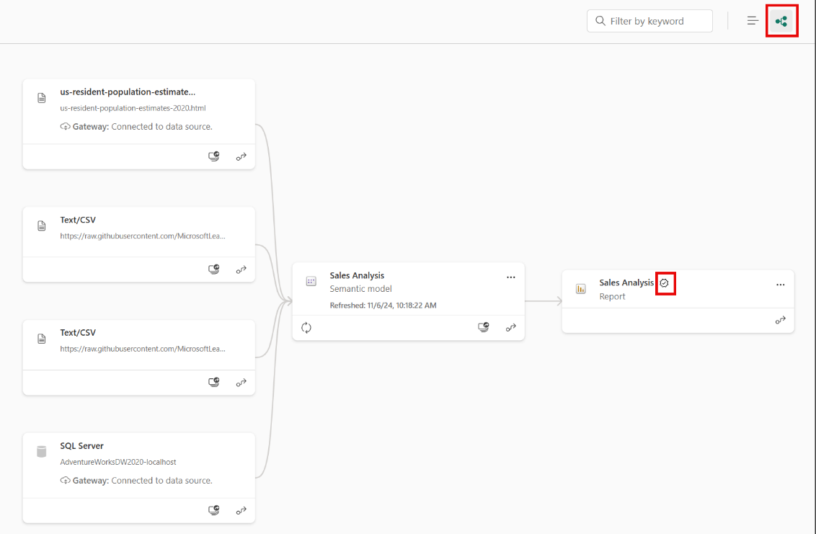
Lineage view allows you to quickly identify dependencies across a workspace for your assets. This view gives you easy administration especially when you have many items in a single workspace. Reviewing lineage view is also sometimes known as impact analysis and is a form of data governance.

Manage a Power BI semantic model using XMLA endpoint
Completed100 XP
- 3 minutes
If you've used Microsoft Analysis Services, you might be familiar with XMLA endpoint. While using an API might feel intimidating to some, it's straightforward to use. In short, the XMLA endpoint is another way for you to connect to Power BI workspaces and semantic models from external applications - just an API with a URL to the workspace or semantic model.

XMLA endpoint settings
By default, endpoint connectivity is read-only for the semantic models workload. This setting allows data visualization tools access to the following semantic model details:
- Model data
- Metadata
- Events
- Schema
Some data visualization tools include Microsoft Excel, Power BI Report Builder, Tabular Editor, or ALM Toolkit. You can get the workspace connection URL in workspace settings.
Read-write connectivity can be enabled to provide more operations, including:
- Management
- Governance
- Advanced semantic modeling
- Debugging
- Monitoring
With read-write enabled, semantic models have more parity with Azure Analysis Services and SQL Server Analysis Services enterprise grade tabular modeling tools and processes. In order to use XMLA endpoint for read-write operations, the semantic model must reside in a Premium or Fabric workspace.
Some common uses of the XMLA endpoint in Power BI are:
- Refreshing individual components of a data model.
- Systematically exporting data from the data model.
- Automating the use of the Best Practice Analyzer.
Note
For full functionality and limitations, reference the Semantic model connectivity with the XMLA endpoint article.

Enforce Power BI model security
- Restrict access to Power BI model data with RLS.
- Restrict access to Power BI model objects with OLS.
- Apply good development practices to enforce Power BI model security.
You can enforce model security by restricting access to subset of data, and by restricting access to specific model tables and columns. Achieving this requirement commonly involves setting up row-level security (RLS), which involves defining roles and rules in that filter data model. You can also set up object-level security (OLS), to restrict access to entire tables or columns.

Restrict access to Power BI model data
Completed100 XP
- 14 minutes
As a data modeler, you set up RLS by creating one or more roles. A role has a unique name in the model, and it usually includes one or more rules. Rules enforce filters on model tables by using Data Analysis Expressions (DAX) filter expressions.
Note
By default, a data model has no roles. A data model without roles means that users (who have permission to query the data model) have access to all model data.
Tip
It's possible to define a role that includes no rules. In this case, the role provides access to all rows of all model tables. This role set up would be suitable for an admin user who is allowed to view all data.
You can create, validate, and manage roles in Power BI Desktop. For Azure Analysis Services or SQL Server Analysis Services models, you can create, validate, and manage roles by using SQL Server Data Tools (SSDT).
You can also create and manage roles by using SQL Server Management Studio (SSMS), or by using a third-party tool, like Tabular Editor.

Apply star schema design principles
We recommend you apply star schema design principles to produce a model comprising dimension and fact tables. It’s common to set up Power BI to enforce rules that filter dimension tables, allowing model relationships to efficiently propagate those filters to fact tables.
The following image is the model diagram of the Adventure Works sales analysis data model. It shows a star schema design comprising a single fact table named Sales. The other tables are dimension tables that support the analysis of sales measures by date, sales territory, customer, reseller, order, product, and salesperson. Notice the model relationships connecting all tables. These relationships propagate filters (directly or indirectly) to the Sales table.
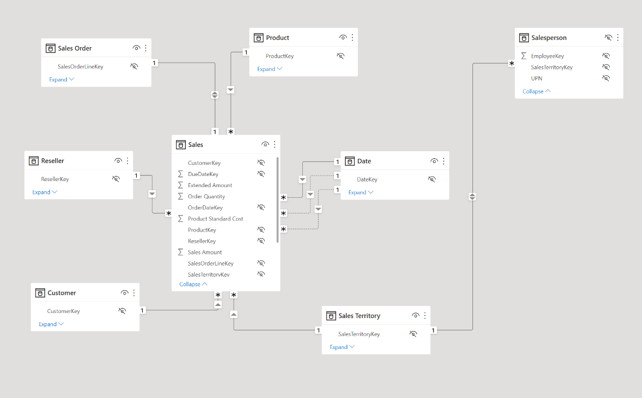
This model design supports examples presented in this unit.

Define rules
Rule expressions are evaluated within row context. Row context means the expression is evaluated for each row using the column values of that row. When the expression returns TRUE, the user can “see” the row.
Tip
To learn more about row context, work through the Add calculated tables and columns to Power BI Desktop models module. While this module describes adding model calculations, it includes a unit that introduces and describes row context.
You can define rules that are either static or dynamic.

Static rules
Static rules use DAX expressions that refer to constants.
Consider the following rule applied to the Region table that restricts data access to Midwest sales.
DAX

'Region'[Region] = "Midwest"

The following steps explain how Power BI enforces the rule. It:
- Filters the Region table, resulting in one visible row (for Midwest).
- Uses the model relationship to propagate the Region table filter to the State table, resulting in 14 visible rows (the Midwest region comprise 14 states).
- Uses the model relationship to propagate the State table filter to the Sales table, resulting in thousands of visible rows (the sales facts for the states that belong to the Midwest region).
The simplest static rule that you can create restricts access to all table rows. Consider the following rule applied to the Sales Details table (not depicted in the model diagram).
DAX

FALSE()

This rule ensures users can't access any table data. It could be useful when salespeople are allowed to see aggregated sales results (from the Sales table) but not order-level details.
Defining static rules is simple and effective. Consider using them when you need to create only a few of them, as might be the case at Adventure Works where there are only six US regions. However, be aware of disadvantages: setting up static rules can involve significant effort to create and set up. It would also require you to update and republish the dataset when new regions are onboarded.
If there are many rules to set up and you anticipate adding new rules in the future, consider creating dynamic rules instead.

Dynamic rules
Dynamic rules use specific DAX functions that return environmental values (as opposed to constants). Environmental values are returned from three specific DAX functions:
- USERNAME or USERPRINCIPALNAME – Returns the Power BI authenticated user as a text value.
- CUSTOMDATA - Returns the CustomData property passed in the connection string. Non-Power BI reporting tools that connect to the dataset by using a connection string can set this property, like Microsoft Excel.
Note
Be aware that the USERNAME function returns the user in the format of DOMAIN\username when used in Power BI Desktop. However, when used in the Power BI service, it returns the format of the user's User Principal Name (UPN), like username@adventureworks.com. Alternatively, you can use the USERPRINCIPALNAME function, which always returns the user in the user principal name format.
Consider a revised model design that now includes the (hidden) AppUser table. Each row of the AppUser table describes a username and region. A model relationship to the Region table propagates filters from the AppUser table.
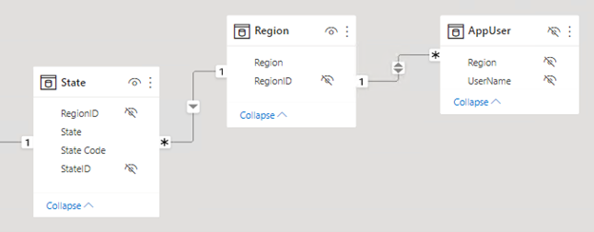
The following rule applied to the AppUser table restricts data access to the region(s) of the authenticated user.
DAX

'AppUser'[UserName] = USERPRINCIPALNAME()

Defining dynamic rules is simple and effective when a model table stores username values. They allow you to enforce a data-driven RLS design. For example, when salespeople are added to, or removed from, the AppUser table (or are assigned to different regions), this design approach just works.

Validate roles
When you create roles, it’s important to test them to ensure they apply the correct filters. For data models created in Power BI Desktop, there’s the View as function that allows you to see the report when different roles are enforced, and different username values are passed.
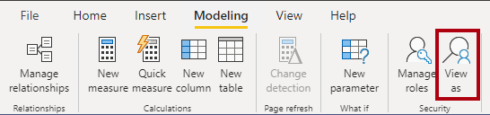

Set up role mappings
Role mappings must be set up in advance of users accessing Power BI content. Role mapping involves assigning Microsoft Entra security objects to roles. Security objects can be user accounts or security groups.
Tip
When possible, it’s a good practice to map roles to security groups. That way, there will be fewer mappings, and you can delegate the group membership management to the network administrators.
For Power BI Desktop developed models, role mapping is typically done in the Power BI service. For Azure Analysis Services or SQL Server Analysis Services models, role mapping is typically done in SSMS.
For more information about setting up RLS, see:
- Row-level security (RLS) with Power BI
- Row-level security (RLS) guidance in Power BI Desktop

Use single sign-on (SSO) for DirectQuery sources
When your data model has DirectQuery tables and their data source supports SSO, the data source can enforce data permissions. This way, the database enforces RLS, and Power BI datasets and reports honor the data source security.
Consider that Adventure Works has an Azure SQL Database for their sales operations that resides in the same tenant as Power BI. The database enforces RLS to control access to rows in various database tables. You can create a DirectQuery model that connects to this database without roles and publish it to the Power BI service. When you set the data source credentials in the Power BI service, you enable SSO. When report consumers open Power BI reports, Power BI passes their identity to the data source. The data source then enforces RLS based on the identity of the report consumer.
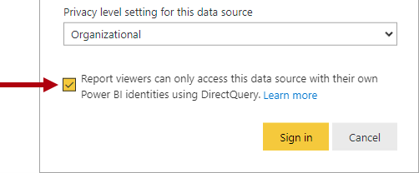
For information about Azure SQL Database RLS, see Row-level security.
Note
Calculated tables and calculated columns that reference a DirectQuery table from a data source with SSO authentication aren’t supported in the Power BI service.
For more information about data sources that support SSO, see Single sign-on (SSO) for DirectQuery sources.

Restrict access to Power BI model objects
Completed100 XP
As a data modeler, you can consider restricting user access to Power BI model objects. Object-level security (OLS) can restrict access to specific tables and columns, and their metadata. Typically, you apply OLS to secure objects that store sensitive data, like employee personal data.
When Power BI enforces OLS, not only does it restrict access to tables and columns, but it can also secure metadata. When you secure metadata, it’s not possible to retrieve information about secured tables and columns by using Dynamic Management Views (DMVs).
Important
Tabular models can hide tables and columns (and other objects) by using a perspective. A perspective defines viewable subsets of model objects to help provide a specific focus for report authors. Perspectives are intended to reduce the complexity of a model, helping report authors find resources of interest. However, perspectives aren’t a security feature because they don’t secure objects. A user can still query a table or column even when it’s not visible to them.
Consider an example at Adventure Works. This organization has a data warehouse dimension table named DimEmployee. The table includes columns that store employee name, phone, email address, and salary. While general report consumers can see employee name and contact details, they must not be able to see salary values. Only senior Human Resources staff are permitted to see salary values. So, the data modeler used OLS to grant access to the salary column only to specific Human Resources staff.
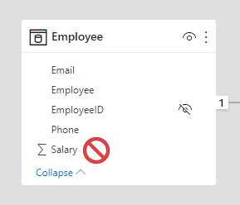
OLS is a feature inherited from Azure Analysis Services (AAS) and SQL Server Analysis Services (SSAS). The feature is available in Power BI Premium to provide backward compatibility for models migrated to Power BI. For this reason, it’s not possible to completely set up OLS in Power BI Desktop.

Set up OLS
To set up OLS, you start by creating roles. You can create roles in Power BI Desktop in the same way you do when setting up RLS. Next, you need to add OLS rules to the roles. This capability isn’t supported by Power BI Desktop, so you’ll need to take a different approach.
You add OLS rules to a Power BI Desktop model by using an XML for Analysis (XMLA) endpoint. XMLA endpoints are available with Power BI Premium, and they provide access to the Analysis Services engine in the Power BI service. The read/write endpoint supports dataset management, application lifecycle management, advanced data modeling, and more. You can use XMLA endpoint-enabled APIs for scripting, such as Tabular Model Scripting Language (TMSL) or the PowerShell SqlServer module. Or you can use a client tool, like SSMS. There are third-party tool options too, like Tabular Editor, which is an open-source tool for creating, maintaining, and managing models.
By default, all model tables and columns aren’t restricted. You can set them to None or Read. When set to None, users associated with the role can’t access the object. When set to Read, users associated with the role can access the object. When you’re restricting specific columns, ensure the table isn’t set to None.
Once you’ve added the OLS rules, you can publish the model to the Power BI service. Use the same process for RLS to map accounts and security groups to the roles.

Considerations
In a Power BI report, when a user doesn’t have permission to access a table or column, they'll receive an error message. The message will inform them that the object doesn’t exist.
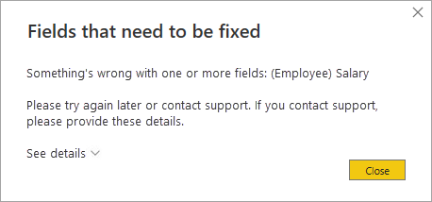
Consider carefully whether OLS is the right solution for your project. When a user opens a Power BI report that queries a restricted object (for them), the error message could be confusing and will result in a negative experience. To them, it looks like the report is broken. A better approach might be to create a separate set of models or reports for the different report consumer requirements.

Restrictions
There are restrictions to be aware of when implementing OLS.
You can’t mix RLS and OLS in the same role. If you need to apply RLS and OLS in the same model, create separate roles dedicated to each type. Also, you can’t set table-level security if it breaks a relationship chain. For example, if there are relationships between tables A and B, and B and C, you can't secure table B. If table B is secured, a query on table A can't transit the relationships between table A and B, and B and C. In this case, you could set up a separate relationship between tables A and C.
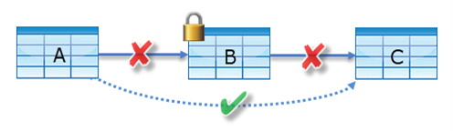
However, model relationships that reference a secured column will work, providing that the column’s table isn’t secured.
Lastly, while it isn’t possible to secure measures, a measure that references secured objects is automatically restricted.
For more information, see Object-level security.
Apply good modeling practices
Completed100 XP
- 3 minutes
It’s critical that your model enforces data permissions correctly and efficiently. The following list provides you with good development practices to apply.
- Strive to define fewer datasets (data models) with well-designed roles.
- Strive to create fewer roles by using dynamic rules. A data-driven solution is easier to maintain because you don’t need to add new roles.
- When possible, create rules that filter dimension tables instead of fact tables. It will help to deliver faster query performance.
- Validate that the model design, including its relationships and relationship properties, are correctly set up.
- Use the USERPRINCIPALNAME function instead of USERNAME function. It provides consistency when validating the roles in Power BI Desktop and the Power BI service.
- Rigorously validate RLS and OLS by testing all roles.
- Ensure that the Power BI Desktop data source connection uses the same credentials that will be applied when set up in the Power BI service.

